
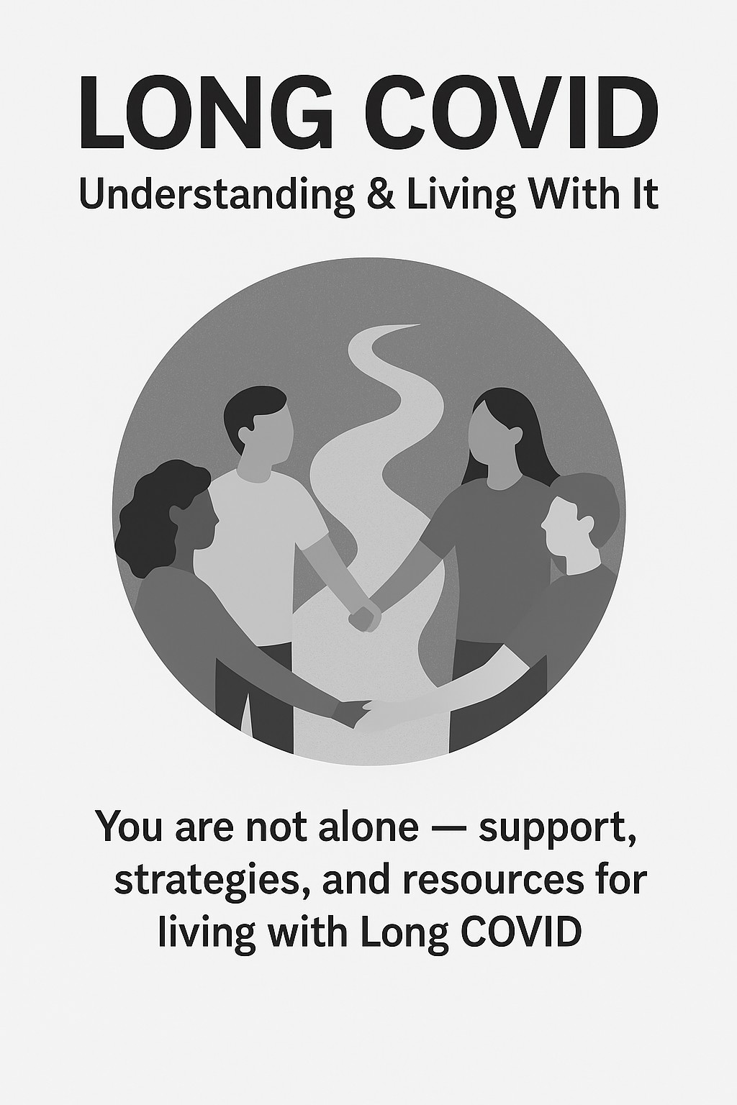

Long COVID: Patient Information & Resources General guidance and support for individuals living with Long COVID, based on recommendations from the American Academy of Physical Medicine & Rehabilitation (AAPM&R), CDC, and local health resources

What is Long COVID? Long COVID is a multi-
system, infection-associated chronic condition that occurs after a COVID-19 infection.
According to the American Academy of Physical Medicine & Rehabilitation (AAPM&R), symptoms last at least 3 months and may present as continuous, relapsing/remitting, or progressive. It can affect people of all ages and may involve multiple organ systems, impacting daily function and quality of life.

Common Symptoms
Individuals suffering with Long COVID can experience various symptoms.
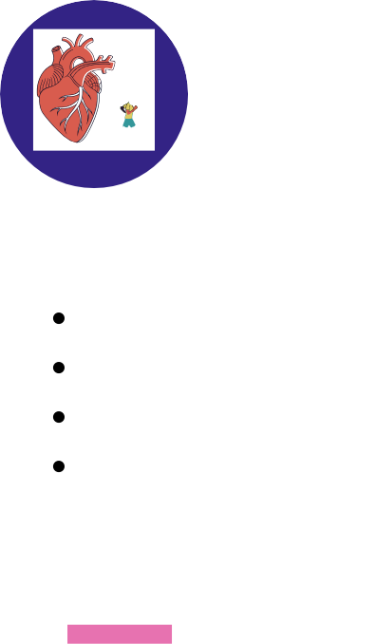

PHYSICAL
Fatigue Palpitations Dizziness Shortness of Breath

COGNITIVE
Brain fog Memory problems Word-finding difficulty Slower processing

MENTAL-EMOTIONAL
Anxiety Depression Grief Trauma Isolation
Other Symptoms May Include but are not limited to:
GI issues, Headaches, Sleep disturbances, and Worsening of other chronic conditions


DIET:
1.
Consider the Mediterranean or MIND Diet
Try to construct each meal or snack according to The Healthy Eating Plate.
Speak with your PCP about dietary guidance or a referral to a Registered Dietician
SLEEP: Focus on good sleep hygiene and establishing healthy sleep routines.
2.
Avoid caffeine late in the day Minimize screen time in the evening
Avoid liquids shortly before bedtime
Maintain a consistent sleep/wake schedule

2a.
Helpful Sleep Tools:
Establish a bedtime routine Reduce screen time prior to sleep.
Work your way up to not using a screen up to 2 hours before bedtime.
Consider eliminating televisions and electronics from the bedroom.
Try different nighttime filters to help decrease blue-light exposure.
Reduce the amount of light in the bedroom at night.
Try meditation techniques that can help you relax and distract you from the worry of not falling asleep
There is a Veterans Administration app Insomnia Coach (https://mobile.va.gov/app/in somnia-coach) to help catalog your sleep and work on setting up a better bedtime routine.

PACING: PRIORTIZE, PLAN,
3.
and PACE
Prioritize- consider which activities are most important
Plan- set aside time each week to list out your activities, tasks, and weekly schedule, set aside time for rest and breaks
Pace- break up large/daunting tasks, evenly spread your tasks throughout the week

Symptom Tracking:
5.
Creating a symptom tracker or journal may be helpful for you and your medical care team

Activity Level
Guidance: AAPM&R recommends a gradual and individualized
4.
approach to activity.
For those
experiencing Post-Exertional Malaise (PEM), avoid
pushing through fatigue.
Begin with recumbent or isometric activity before
progressing to resistance or cardio.
Shared decision-making with your provider is essential to ensure safe pacing.


Identifying triggers or activities that could be worsening your symptoms can be a useful tool. Doing so may help you learn how to effectively pace yourself during your recovery from
COVID-19. Learning how to limit overexertion by pacing or “budgeting your energy” may help ensure that you have enough energy to complete essential and enjoyable tasks
Other Methods to Symptom Track: Good Days and your Bad Days by the Bateman Horne Center
Phone Applications: visible. https://www.makevisible.com/ and Bearable https://bearable.app/
Symptom Tracking Example:
Date | Activity | Activity Type | Time Spent | Symptoms | Severity of Symptom(s)
10/1 | Walking | Physical | 20 min | Fatigue | 4
10/2 | Dinner w/ Friends | Emotional/ Social | 1 hour | Fatigue | 6
10/3 | Work (comput er) | Cognitive | 4 hours | Brain Fog | 3

Step 1: Record the type activity you participated in.
Step 2: Record the amount of time you spent on the activity. Step 3: Categorize the activity by the type of exertion. We recommend categorizing activities into 3 groups 1) Physical
2) Cognitive 3) Social/Emotional. Step 4: Record your symptoms associated with the activity.
Additionally, if the activity did not elicit any symptoms, record that as well.
Step 5: Determine how severe symptoms were. We recommend using a scale (0 being the least severe, 10 being the most severe)

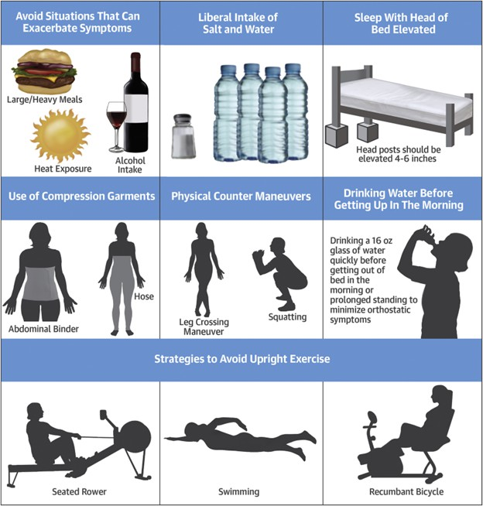
Strategies for Minimizing Symptoms of POTS (Postural Orthostatic Tachycardia Syndrome)
From: Bryarly M, Phillips L, Fu Q, et al. Postural Orthostatic Tachycardia Syndrome. J Am Coll Cardiol. 2019 Mar, 73 (10) 1207–1228.
https://doi.org/10.1016/j.jacc.2018.11.059

PLEASE DISCUSS SALT INTAKE WITH YOUR PRIMARY CARE PROVIDER.
IF YOU HAVE RENAL (KIDNEY) OR CARDIAC (HEART) DISEASE, INCLUDING HYPERTENSION, PLEASE DISCUSS SALT INTAKE WITH YOUR MANAGING PROVIDER

Mental Health Support
Patients with Long-COVID may experience mental health symptoms both due to the difficulties of living with chronic symptoms as well as directly due to the
inflammatory effects of the disease.
Many find it helpful to work with mental health professionals when experiencing symptoms like
depression, anxiety or insomnia in the context of Long-COVID.
Treatments for mental health challenges associated with Long-COVID may include medication and/or talk therapy

Considerations

Connecting with others can be very helpful.
Building connections can help remind you that you are not alone. Attending a support group or listening to a podcast may be a helpful way to make these connections.
At this end of this packet you will find a PDF about Long-COVID Support

In addition to mental health evaluation and treatment, psychotherapy can be helpful for a variety of issues related to Long-COVID. Psychotherapy may help patients with Long-COVID address concerns, such as coping with grief and life changes as a result of illness, managing anxiety about the future, changing lifestyle habits to enhance wellbeing, and rebuilding a meaningful life. This can include the use of therapies like Acceptance and Commitment Therapy or Cognitive Behavioral Therapy (CBT), and/or trauma-focused therapies

2 Support Groups:
UCHealth North: Long COVID support group in northern Colorado -
UCHealth Today
Bateman Horne
Center: Long COVID Patient Education -
Bateman Horne Center

Resources:

General Information:
Colorado Department of Public Health, Long COVID. Long COVID | Department of Public Health & Environment (colorado.gov)
CDC, Long COVID Basics. Long
COVID Basics | CDC
AAPM&R, Long COVID/PASC.
Long COVID/PASC (aapmr.org)
Long Covid The Answers: Long Covid The Answers – The Credible Destination for Everything Long Covid
CU Anschutz CO-MTN: Colorado Multidisciplinary Translation Network (CO-MTN) Home

Disability and Work Related:
Department Of Health and Human
Services, Guidance on “Long COVID” as a Disability. Guidance on “Long COVID” as a Disability Under the ADA, Section | HHS.gov
Office of Disability Employment Policy, Working with Long COVID.
Working_with_Long_COVID.pdf (dol.gov)
Allsup SSDI National Social
Security/Disability Representatives Phone: 1-800-405-8339 Website: www.allsup.com
Division of Vocational Rehabilitation: Website: dvr.colorado.gov.
Medicaid for Working Adults with Disabilities (uses SSA criteria 2 and 3 only to evaluate disability status)
https://hcpf.colorado.gov/health-first-colorado-buy-in programs#BUYIN-
ADULT

A Misunderstood Disabling Chronic Illness:

How You Can Support Loved Ones Living with Long-COVID
Long-COVID Facts
Long-COVID is defined as experiencing long-term effects after an infection of COVID-19.
- Affects 1 in 5 adults who have had COVID-19 in the last year
- Impacts people of all ages regardless of their health status
- Is considered a disability under the ADA, Section 504, and Section 1557


Impact of Long-COVID
Long-COVID symptoms present differently for each person and occur with varying degrees of severity. This condition often leads to a drastic change in ability to function, which can vary from day-to-day.
The symptoms are often unpredictable and can lead to feeling a loss of control while also trying to continue forward with their life.
The common symptoms and challenges are listed below, however, do not fully capture all Long-COVID experiences.

Common Symptoms Common Challenges
Exacerbation of other medical conditions, decreased ability to be active, need for more breaks, need for more time to complete tasks

Physical
Fatigue, body aches, pain, nausea, dizziness, vomiting, heart palpitations

Cognitive
Brain fog, word finding and memory problems, difficulty concentrating

Emotional

Anxiety, depression, trauma, isolation, grief, identity changes, relationship distress
Difficulty scheduling and planning, forgetting conversations, needing reminders to complete tasks, slower talking, losing track of conversations
Increased sleeping, crying, isolation and self-criticism; not engaging in previously enjoyed activities, fear of leaving the house, changes in social engagement, becoming easily overwhelmed

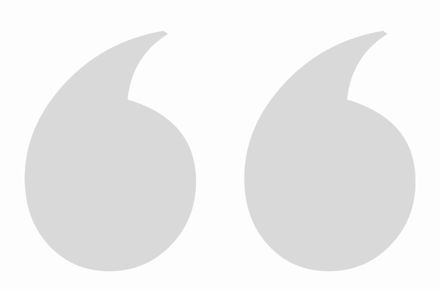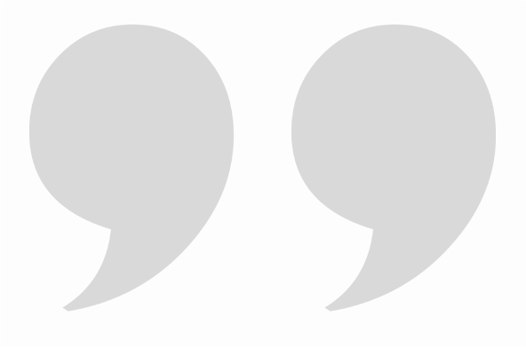
Messages from People Living with Long-COVID
I’m doing the best I can to function and survive, even though:

I’m grieving the change in my health, ability to work, relationships, and future.
Long-COVID symptom variation prevents me from planning far in advance and having a consistent routine.
That can feel overwhelming, chaotic, and dysfunctional.

Many of my Long-COVID symptoms are “invisible.” Other people can’t easily see them, but that doesn’t make them any less real.

I don’t know how I’ll feel day to day, or moment to moment.
Managing physical symptoms is physically and emotionally taxing, which impacts my cognitive functioning and can impair my ability to advocate for appropriate care.

The unknown of Long-COVID is exhausting and frustrating. There is still a lot for everyone to learn and understand about Long-COVID.
How can I be supportive?
Practical and Physical
- Supporting loved ones with Long-COVID includes listening to what might be most helpful to them specifically. Each person has specific needs and knows themselves best.
- Remind your loved one to take breaks and rest regularly, and more as needed.
- Help your loved one with tasks that require significant time and energy.
- Assist with scheduling and helping your loved one get to healthcare appointments.
- Attend healthcare appointments with your loved one and take notes.
- Help advocate for their best interest and values and aim to be their voice when they are unable to speak up.
- Help your loved one find information about Long-COVID and understand new information as it becomes available.
Emotional
- Listen and validate your loved one's experience. Aim to be compassionate, understanding, and kind.
- Understand that your loved one might be easily overwhelmed and may not have the emotional capacity to take on additional stressors.
- Offer to do low-stress and enjoyable activities together, with flexibility for changing plans, postponing plans, and taking breaks. Ask your loved one what those activities might be for them.
- Encourage loved ones to engage in movement and stress management that works for them.
- Help them find additional avenues of social support, including groups, individual therapy, and ways to virtually connect with others.

- https://www.cdc.gov/coronavirus/2019-ncov/long-term-effects/care-post-covid.html
- https://www.longcovidsos.org
Resources for More Information:
- https://www.wearebodypolitic.com/covid-19

Communicating impaired function can be challenging for people ME/CFS, FM, OI, and Long COVID. In addition, clinicians often lack the time and tools to fully grasp the extent of impairment. BHC developed a simple questionnaire that helps patients to communicate the frequency, severity, and nature of their activity limitations.
Estimating the number of better (GOOD) versus worse (BAD) days and listing specific examples communicates the range of function.
Hours of Upright Activity (HUA), or time spent with feet on the floor (sitting, standing, walking) versus time
spent with feet elevated in 24 hours, takes a little thinking but clearly communicates tolerance for upright activity.
Download, print, and fill out this questionnaire for your provider.

GOOD DAYS
While there may never be a true “good” day with chronic illness, there are “better” or more functional days. Indicate your hours of upright activity and ability to perform tasks on good or better illness days.
How many good days do you average in a month?
In a 24-hour period, how many hours of upright activity do you engage in on a good day?
How many hours of non-upright activity (feet elevated, lying flat) do you engage in?
For the following, consider:
- Activities of daily living include things like dressing, bathing, preparing food, etc.
- Cognitive processing (reading, writing, answering text messages/emails, holding conversations, etc.)
- What other areas/aspects of daily living are affected by your illness?

Give examples of activities/tasks you CAN do on a GOOD Day:

Give examples of activities/tasks you CANNOT do on a GOOD Day:
BAD DAYS
Indicate your hours of upright activity and the level of function you experience on bad or worsened illness days.

How many bad days do you average in a month?
In a 24-hour period, how many hours of upright activity do you engage in on a bad day?
How many hours of non-upright activity (feet elevated, lying flat) do you engage in?
For the following, consider:
- Activities of daily living include things like dressing, bathing, preparing food, etc.
- Cognitive processing (reading, writing, answering text messages/emails, holding conversations, etc.)
- What other areas/aspects of daily living are affected by your illness?

Give examples of activities/tasks you CAN do on a BAD Day:

Give examples of activities/tasks you CANNOT do on a BAD Day:


Good Day/Bad Day Questionnaire
Name: Date:

batemanhornecenter.org May 10th, 2022

