Instructions to Complete CPI 3.0 Training Modules

We appreciate your commitment to providing excellent clinical education experiences for our CU DPT students! Below you’ll find step by step instructions on how to complete the CPI 3.0 training via the APTA Learning Center.
This training is FREE to both APTA members and Non-members.

Open a web browser and navigate to the APTA Learning Center: https://learningcenter.apta.org/
Next search for CPI 3.0

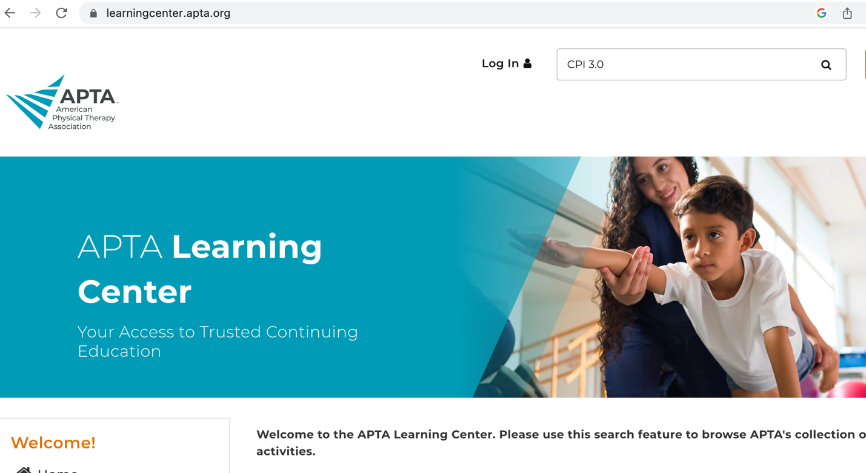

Click the APTA CPI 3.0 – CI/SCCE Training.

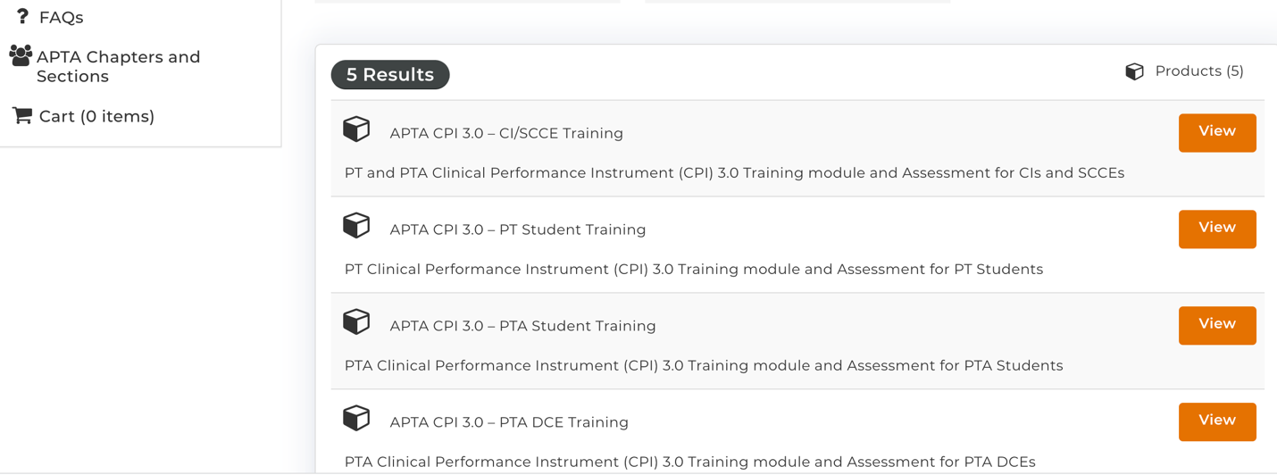

Click Register in right hand corner of your screen.

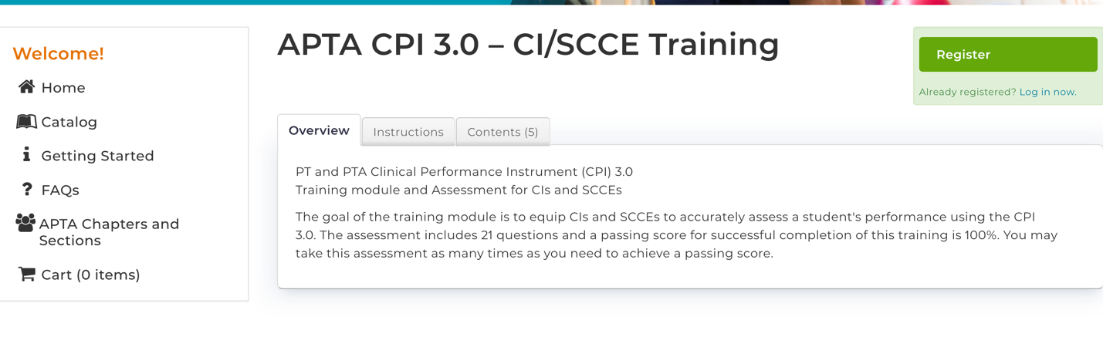
Both APTA members and Non Members may register.
If you’re an APTA member, you will be prompted to log in.
If you are a non member, Click “Create a Free Account” at the bottom of the screen.
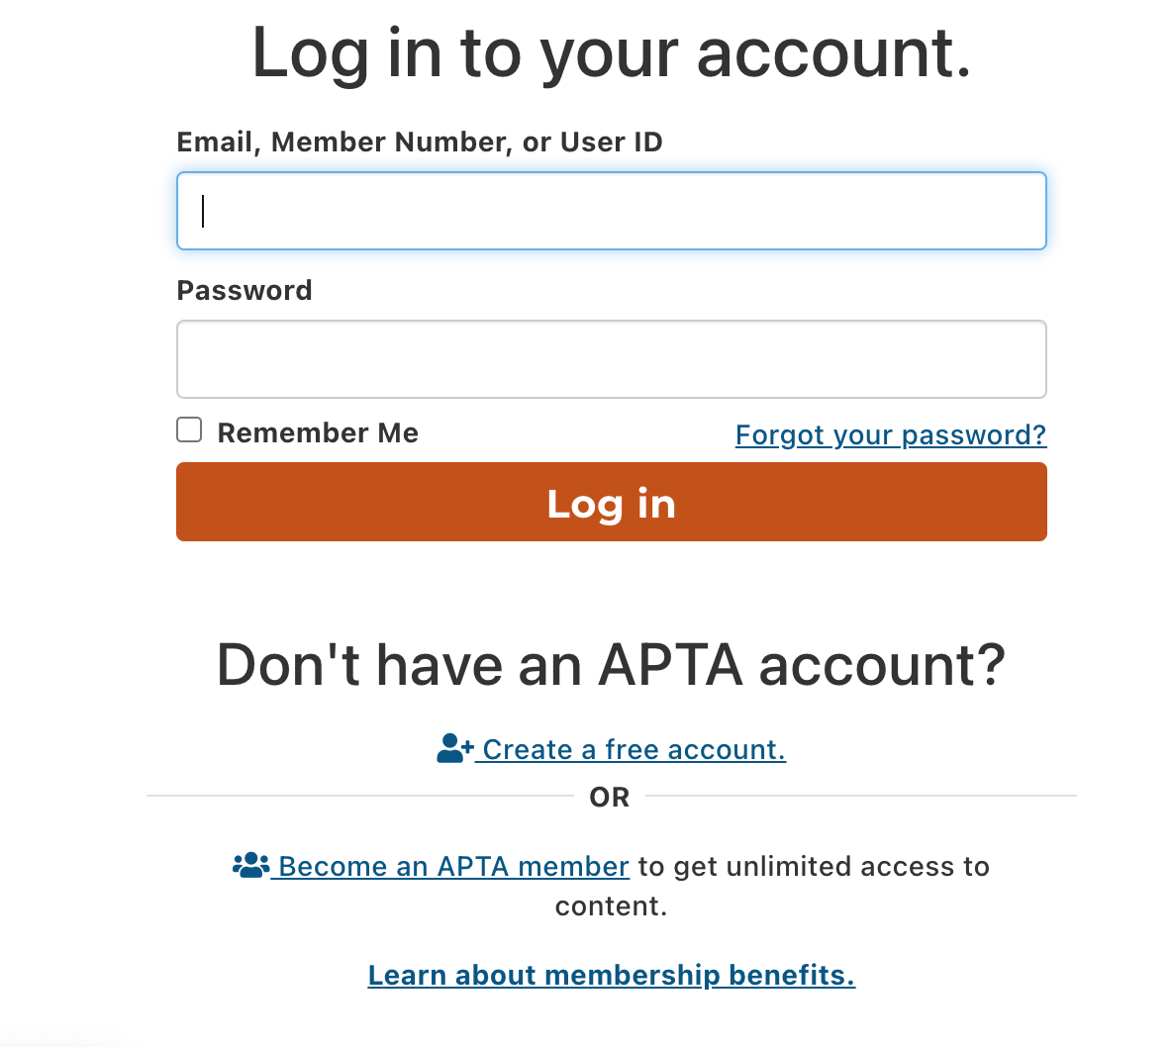
Non-member Sign Up
Member Log in

For Non-members: You will next be prompted to create an account.

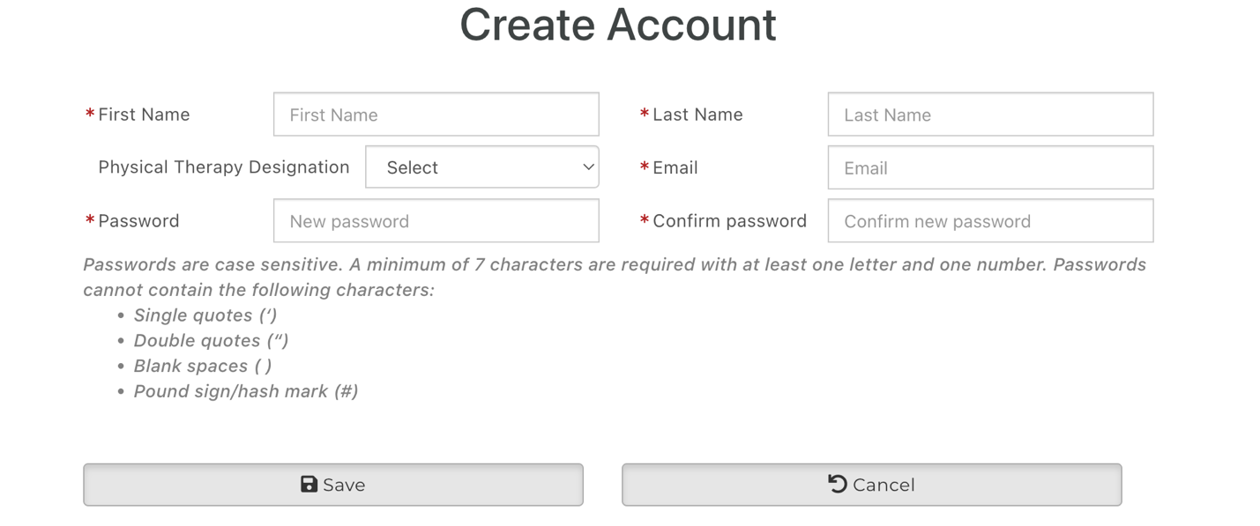

Once registered, you may begin the training. Click View Video on right to start.

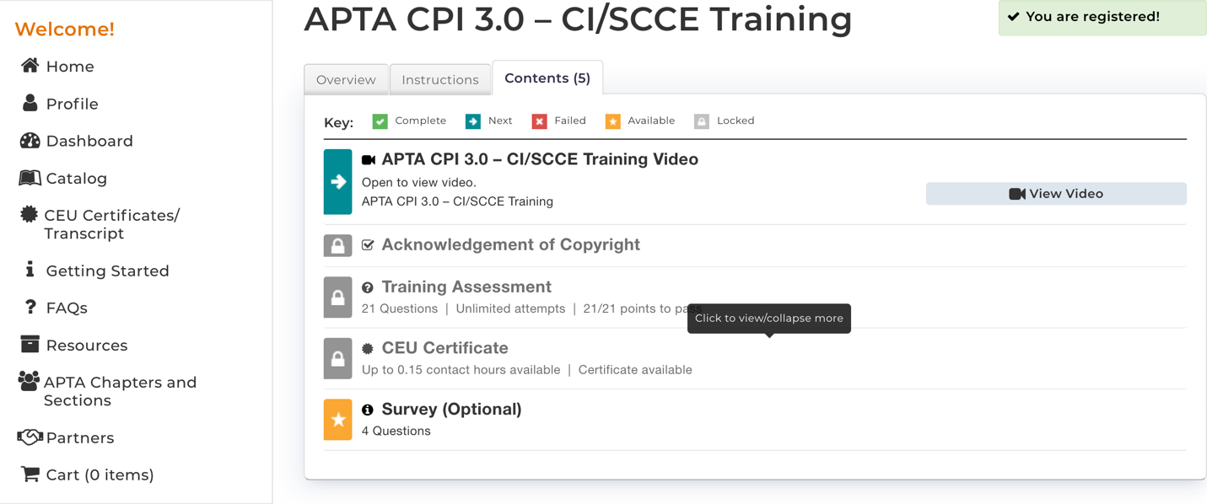

Once training is completed, your screen will have all green check boxes. You will be able to print your training certificate.
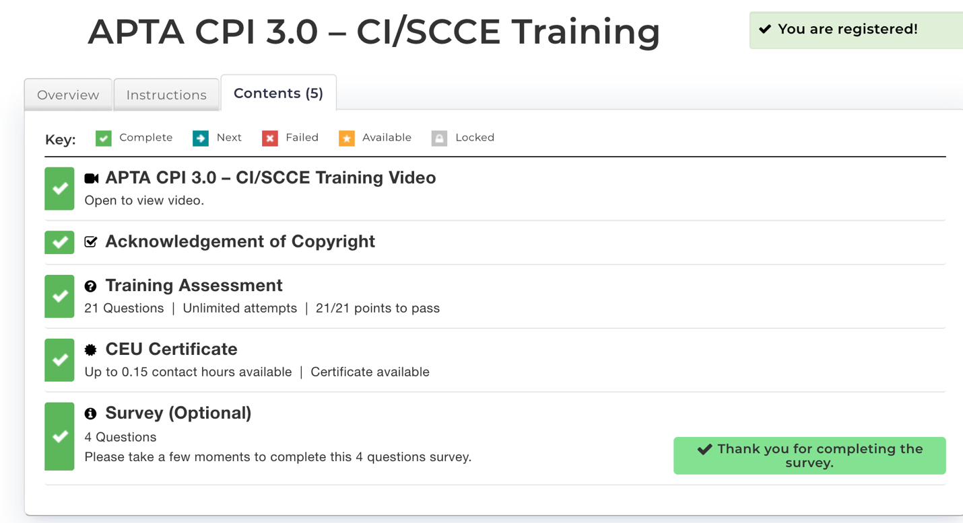

Access to the CPI 3.0 platform will be managed through the APTA and you will use the same email/password you used for the Learning Center training. The platform for completing the CPI 3.0 can found at the following link: https://cpi.apta.org/.

