University of Colorado School of Medicine-Department of Pathology
Supplemental Form for Fellowship Application
Applicant Full Name:

Indicate the fellowship program to which you are applying:
__Blood Banking/Transfusion Medicine
__Breast & Gyn Pathology
__Cytopathology
__Forensic Pathology
__GI & Liver Pathology
__Hematopathology
__Molecular Genetic Pathology
__Pediatric Pathology
__Soft Tissue Pathology
__Surgical Pathology

Indicate the Training Period for which you are applying (example 2020-2021):

OPTIONAL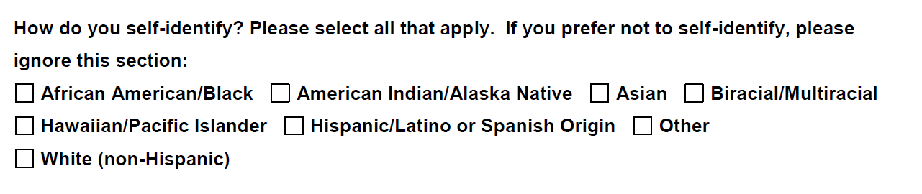

Please submit the following to the Fellowship Coordinator (electronic submission is preferred):
Completed Application form
This (signed) supplemental form
Updated Curriculum vitae (CV)
Personal Statement
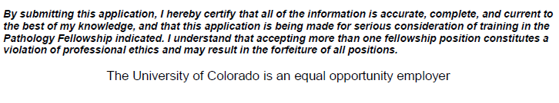
Applicant Signature:

Date:

