Faculty
Third Annual Course for Microscopic and Endoscopic
Approaches to the Skull Base

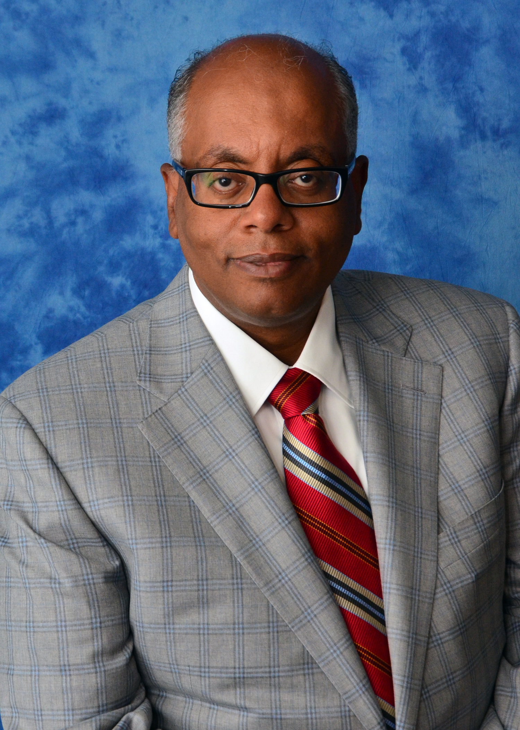 | Khaled Aziz, MD, PhD  Drexel University | 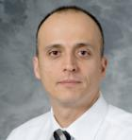 | Mustafa Baskaya, MD  University of Wisconsin
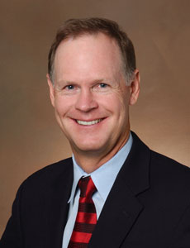 | Stephen Cass, MD, MPH  University of Colorado | 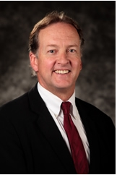 | William Couldwell, MD, PhD  University of Utah
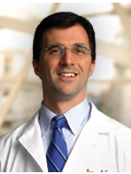 | James Evans, MD  Thomas Jefferson University |  | Sebastien Froelich, MD  Paris VII – Diderot University
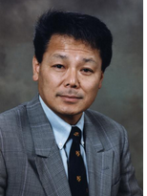 | Takanori Fukushima, MD  Duke University | 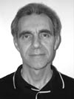 | Fred Gentili, MD  University of Toronto
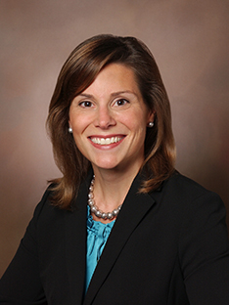 | Anne Getz, MD  University of Colorado | 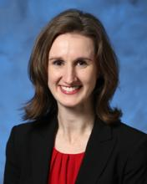 | Julie Goddard, MD  University of Colorado
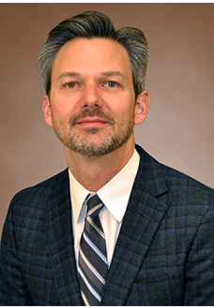 | Samuel Gubbels, MD  University of Colorado | 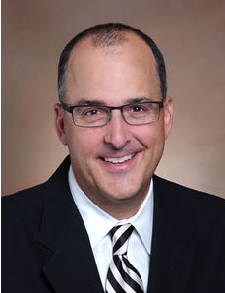 | Todd Kingdom, MD  University of Colorado
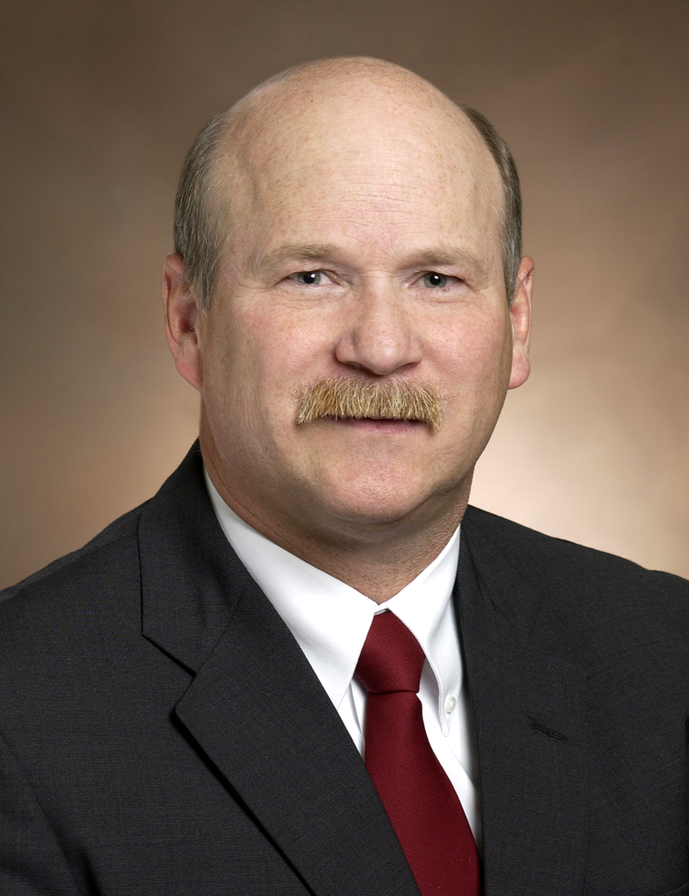 | Kevin Lillehei, MD  University of Colorado | 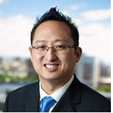 | James Liu, MD  Rutgers University
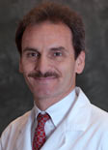 | Jacques Morcos, MD  University of Miami | 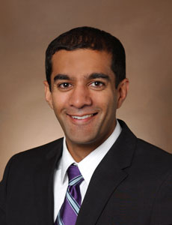 | Vijay Ramakrishnan, MD  University of Colorado
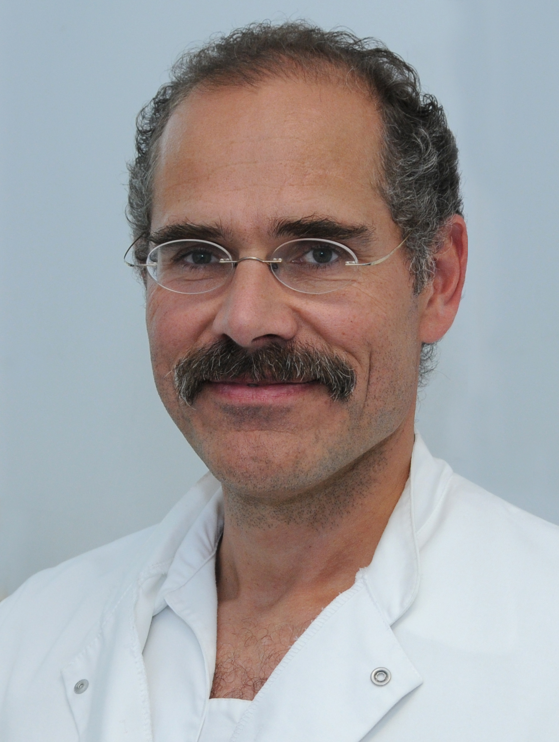 | Henry Schroeder, MD  Ernst Moritz Arndt University  Germany | 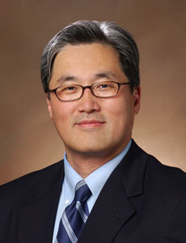 | John Song, MD  University of Colorado
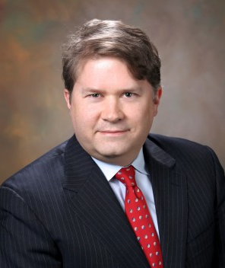 | Jeffrey Sorenson, MD  University of Tennessee | 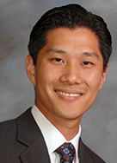 | Jeffrey Suh, MD  UCLA
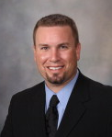 | Jamie Van Gompel, MD  Mayo Clinic | 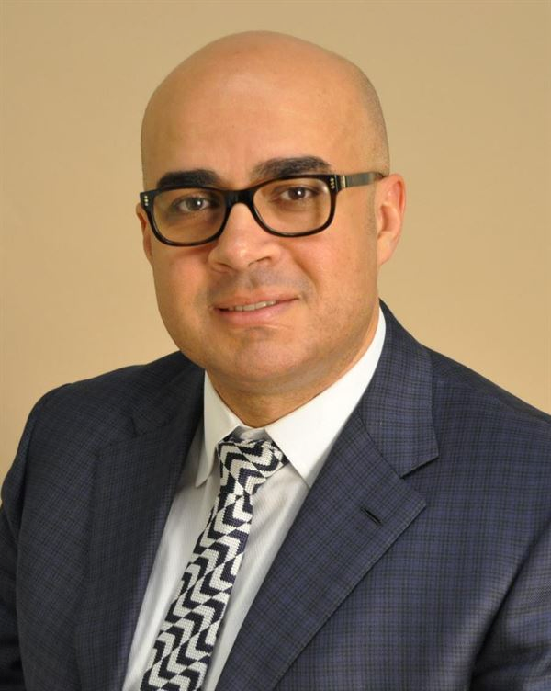 | A. Samy Youssef, MD, PhD  University of Colorado

