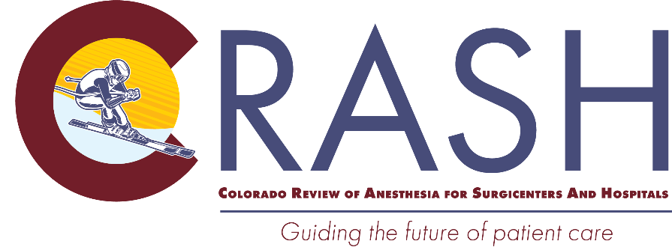

To our valued 2026 CRASH Attendees:

In just a short time, you will join over 300 of your colleagues from around the world to learn more about how to help improve perioperative outcomes by reviewing the latest in cardiac, obstetrical, pain management, and pediatric anesthesia. To help you make the most of your time at CRASH, please refer to the information below.
CRASH Mobile App:
You will receive an email prior to the conference with an invitation to download the Engagefully mobile app created for CRASH 2026. More information will be provided in the email.

Conference Registration/Check-In:
Registration will be in the lower level of the Hythe near the Grand Ballroom. Please look for signage upon your arrival to direct you to the registration area. Registration will be open:
- Sunday, 12:00 p.m. – 8:00 p.m.
- Monday – Thursday, 6:30 a.m. – 9:30 a.m. and 3:30 p.m. – 7:00 p.m. (we will close at 6pm on Tuesday)

By Day Registrations:
If you are registered for only specific days of the conference vs. the full conference it will be noted on your name badge.

You will only be able to claim CME credits for the days you are registered for and can only attend breakfast and the Après Reception on the days you have registered for. We will be monitoring the area and checking badges and appreciate your cooperation.

Location:
CRASH is located at The Hythe. The address for the hotel is 715 West Lionshead Circle, Vail, CO 81657. Check-in is at 4:00 pm, Check-out is at 11:00 am.

Parking & Restaurant Discount:
Everyone booked within the CRASH Group will receive a 20% discount on parking, just mention you are with the CRASH conference at the Valet. Also, CRASH attendees can receive 10% off lunch or dinner in hotel’s on-site restaurant (does not include tax, gratuity or alcohol).

Meals:
The conference will provide breakfast Monday – Thursday, and après-ski Receptions Sunday-Thursday, the hosted bar will be open from 3:30-4:30 p.m. during the après-ski, with a cash bar available until 5:30pm. There will be an opening reception on Sunday evening, from 6:30 p.m. – 8:00 p.m.

IF YOU HAVE A DIETARY ALLERGY THAT WAS NOT ALREADY PROVIDED, PLEASE EMAIL CHRISSIE.BUTZ@CUANSCHUTZ.EDU NO LATER THAN FEBRUARY 17TH
SO WE CAN DO OUR BEST TO ACCOMMODATE YOU.

Guests:
Everyone attending the breakfasts and Après Reception each day must be registered to attend and wear their name badge in the conference area. If you have a guest(s) you would like to add, please visit the registration desk for information and payment.

Ground Transportation:
We have arranged for a group discount with Epic Mountain Express (subject to availability). Please feel free to book your transport through Epic Mountain Express and use the group code CRASH26 to get our arranged rate for service.

Lift Tickets:
If you purchased EPIC passes, you should have received an email directly from EPIC to go into your account and upload your photo and complete their process. Once that is done you will receive your pass prior to CRASH directly from them, we will not have these passes onsite at CRASH.

Equipment Rental:
Charter Sports is a full-service ski and snowboard rental shop located at Lion Square North. CRASH 2026 attendees are eligible for the following discounted ski and snowboard rental rates as well as the most professional customer service in the Vail Valley.
You can book your ski and snowboard rentals in any of the following ways:
- BOOK ONLINE through the group's reservation page: CRASH 2026-Group Booking Link-Save 35%
- Call Charter Sports at 888-295-9797 and reference CRASH 2026 to receive the group rate.
NOTE: If you plan to take a day off, you will need to bring the equipment back to Charter Sports for that day, so you do not get charged. Reservations must be booked a week in advance, or you may not be eligible to receive the group discount.
Charter Sports is conveniently located on the way to the Eagle Bahn Gondola within a two minute walk from the Hythe Vail. A credit card is requested to complete reservations; however, final payment is not collected until guests pick up their equipment (policies subject to change).

Conference Syllabus:
The conference syllabus will be available both in the Engagefully mobile app and on the conference website CUCRASH.org.

CME:
Evaluations for the Colorado Review of Anesthesia for Surgicenters and Hospitals (CRASH) 2026 will be provided electronically using Survey Monkey with the ability to claim CME credit and/or ABA MOCA credit (including up to 21 credits for Patient Safety).

- This year, the evaluation QR code/link will be provided in your registration packet and onsite at CRASH during the week. At the end of the course, you must complete this survey to claim CME credits.
- You MUST complete the survey before 5 pm on Sunday, March 15th to receive credit and claim your certificate.
- Your CME certificate will be emailed to you directly from the CME Office March 16th.
- ABA MOCA data will be reported directly to ABA on March 16th.

Accreditation and Designation Statement
The University of Colorado School of Medicine is accredited by the Accreditation Council for Continuing Medical Education (ACCME) to provide continuing medical education for physicians.

The University of Colorado School of Medicine designates this live activity for a maximum of 22.5 AMA PRA Category 1 Credits™. Physicians should claim only the credit commensurate with the extent of their participation in the activity.

ABA MOCA with Patient Safety Statement

This activity offers up to 22.5 CME credits, of which 21 credits contribute the patient safety CME component of the American Board of Anesthesiology’s redesigned Maintenance of Certification in Anesthesiology™ (MOCA®) program, known as MOCA 2.0®. Please consult the ABA website, www.theABA.org, for a list of all MOCA 2.0 requirements.

To earn board credit, the attendee must participate in the CME activity including the evaluation component. By participating in this event and requesting board credit, I understand that my learner completion data will be shared with the ACCME and the applicable certifying board(s).

CRNA’s:
CRNA’s must complete the specific AANA evaluation provided hard copy to you at the CRASH registration desk in order to claim AANA credits. Please return the survey packet to the registration desk before you leave the conference. After the conference, Conference Coordinator Chrissie Butz will upload your credits to the AANA, and you will receive a certificate through email.


AA’s:
AA’s will need to self-report your AMA credits to the NCCAA to receive credit.

Questions?
For more information please visit the CRASH website or contact Chrissie Butz at Chrissie.butz@cuanschutz.edu.

Safe travels and we look forward to seeing you soon!

Richard Ing, MD Bethany Benish, MD Chrissie Butz
Professor, Director of Clinical Research Associate Professor Conference Coordinator
Pediatric Anesthesiology, Conference Co-Director Chrissie.butz@cuanschutz.edu
Vice Chair of Faculty Development
CRASH Course Director





IN CASE OF EMERGENCY INFORMATION

How Attendees Will be Notified:
In the event of an emergency that requires CRASH 2026 attendees to evacuate The Hythe attendees will be notified by both the hotel Fire Alarm system and University of Colorado event staff.

Evacuation:
If an emergency occurs while attendees are in session in the Grand Ballroom, please exit the ballroom, go through the foyer, past the elevators and out the doors to the right of the Hythe Spa. This exit will take you out the back of the hotel. You will then proceed to the left down the path to the Arrabelle Parking Garage (Muster Station). Please check in with Chrissie so we can account for everyone.

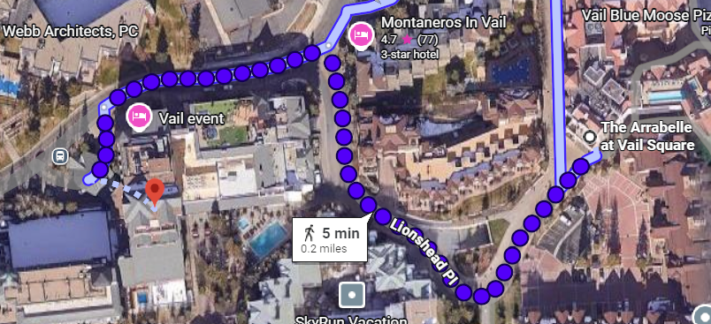

The Hythe

If the event prompting an evacuation is occurring In the West Wing of the building the muster point is the Arrabelle Parking Garage. If it is in the East Wing of the building the muster point is the Ritz Carlton parking garage. If it is in the Center Wing the muster point is determined by which wing you are in, West goes to the Ritz Carlton parking garage and East goes to the Arrabelle parking garage.

