COVID Case Data
https://covid19.colorado.gov/data
Colorado Vaccination Data
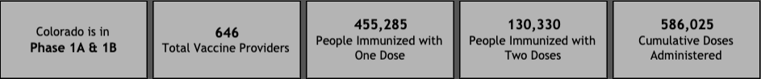
https://covid19.colorado.gov/vaccine
Excess Mortality from Non-COVID Causes. Speaker: Kirk Bol, MSPH
- Information gathered from cause of death portion of death certificate
- 4,700 deaths due to COVID-19 in Colorado, 10% of all deaths in Colorado for 2020
- 46,000 total deaths in 2020, 39,000 for 2019
- Since the end of March 2020 we have consistently had excess mortality (ie. increased weekly deaths more than ~10% greater than the normal average for that time of year)
  - Much of this is due to COVID-19
  - However, some weeks the excess mortality was due to non-COVID dx
- Excess mortality by underlying cause of death
  - Influenza PNA - minimal change in 2020
  - Chronic lower respiratory disease (COPD, etc) - no significant increase
  - Circulatory disease
    - No significant changes in ischemic heart disease or heart failure
    - Some increase in cerebrovascular disease (stroke, hemorrhage, etc), especially stroke mortality.
    - Increase in hypertensive diseases related mortality throughout pandemic
  - Some general trend towards increase in mortality due to neoplasm (cancer)
  - One of the biggest drivers of excess mortality is alzheimers and dementia related mortality, especially early in the pandemic (long term care facilities, memory facilities). This has been true throughout the pandemic.
  - Diabetes mortality saw increase in 2020 compared to prior years
  - Renal failure had a very slight increase. Sepsis was stable.

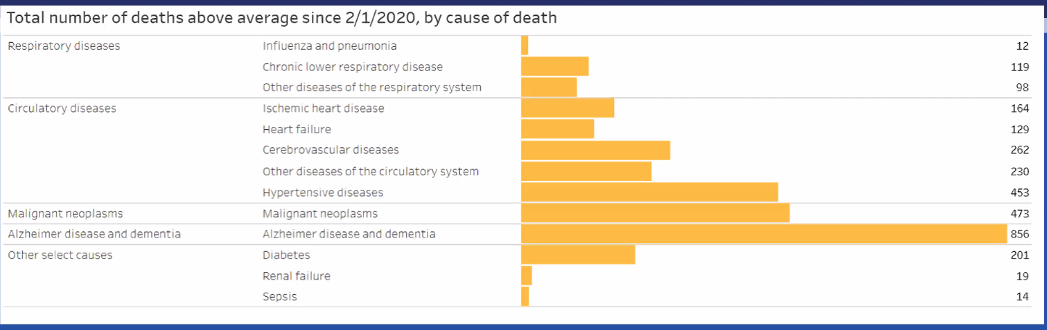
Additional Questions and Answers

- I've seen COVID-19 noted as the #3 cause of death in the US, do we know where it ranks for Colorado specifically?
  - Not exactly at the moment, we don't have final data for 2020, though we do know it will be in the top 10. There were periods where COVID was in top 3 though ranking fell somewhat. Will likely be in top 5.

- Is there any error introduced by looking at total number of deaths rather than death per total population or has Colorado's population been stable enough for this not to matter.
  - Good question, Colorado’s population has experienced considerable and rapid growth over time. The data comparing 2020 to prior years does need to be seen with a bit of a critical lens. This data will be teased out further in final reports, though in other analysis this excess mortality has persisted when controlling for total population

- Does the data on non-COVID causes of deaths exclude patients who had COVID-19, or could there be overlap in this data?
  - There would be some overlap there, these excess mortalities may include patients who listed COVID-19. This will be parsed out in more final reports.

- Can you comment further on the "hypertensive diseases". I assume this was mortality due to stroke and MI in patients with HTN?
  - Hypertensive (HTN) disease would reflect deaths for where primary system HTN was the issue, and categories are designed to be mutually exclusive. This would not include stroke.

- Further comments, if any, on increased mortality in dementia?
  - Many Alzheimer's and dementia deaths did have overlap with COVID-19, this is a category that warrants further investigation. Isolation may be a contributing factor to this as well.

- Have we seen efforts by our health systems to proactively address factors that have led to excess mortality as yet? If so, examples?
  - I don’t necessarily have an exact example of how our health system might be addressing this issue. We do hope that our data can help raise further awareness on this issue so that it can be addressed.

- Can you speak to how influenza mortality in winter 2020 - spring 2021 compares to past years?
  - So far as we’ve seen, Influenza mortality has been pretty mild so far. From a mortality standpoint I am expecting mortality to be lesser than in prior years.

- Who does the work on teasing out some of the potential confounding data as well as more in depth exploration?
  - CDPHE as well as academic medicine, we welcome ideas on further research using this data.

- Do you think it would be fair to look at mortality as 'the tip of the iceberg' suggesting that excess morbidity has been much higher. Is anyone investigating morbidity issues?
  - I don’t have a really good answer for this unfortunately, increased mortality could be due to changes in mortality rate or changes in overall prevalence of these conditions. We do know that the prevalence of conditions like DM and HTN have been increasing over time, and could affect comparison to previous years.

