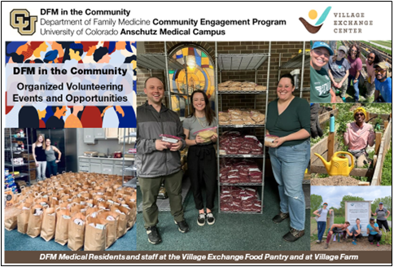  - June 2025  DFM in the community  DFM in the Community provides organized opportunities for all members of the Department of Family Medicine to learn about, support, or volunteer at a community-serving organization. We pull together the information about a featured community partner and identify ways we can support them as a department.Our team does the coordinating and information gathering for you, so all you need to do is sign up and show up. Remember - Your time is covered! The University of Colorado allows for employees to use up to 4 hours annually to volunteer at a community organization. Record your time (maximum of 4 hours) as "Volunteer-Administrative Leave" in your timesheet or in MyLeave. DFM in the Community is a great way to learn about, and give back to, the communities we serve. It also is a fun way to spend time with your colleagues outside of the office!
  Wednesday, June 11 (Pantry), 1:00pm-4:00pm
  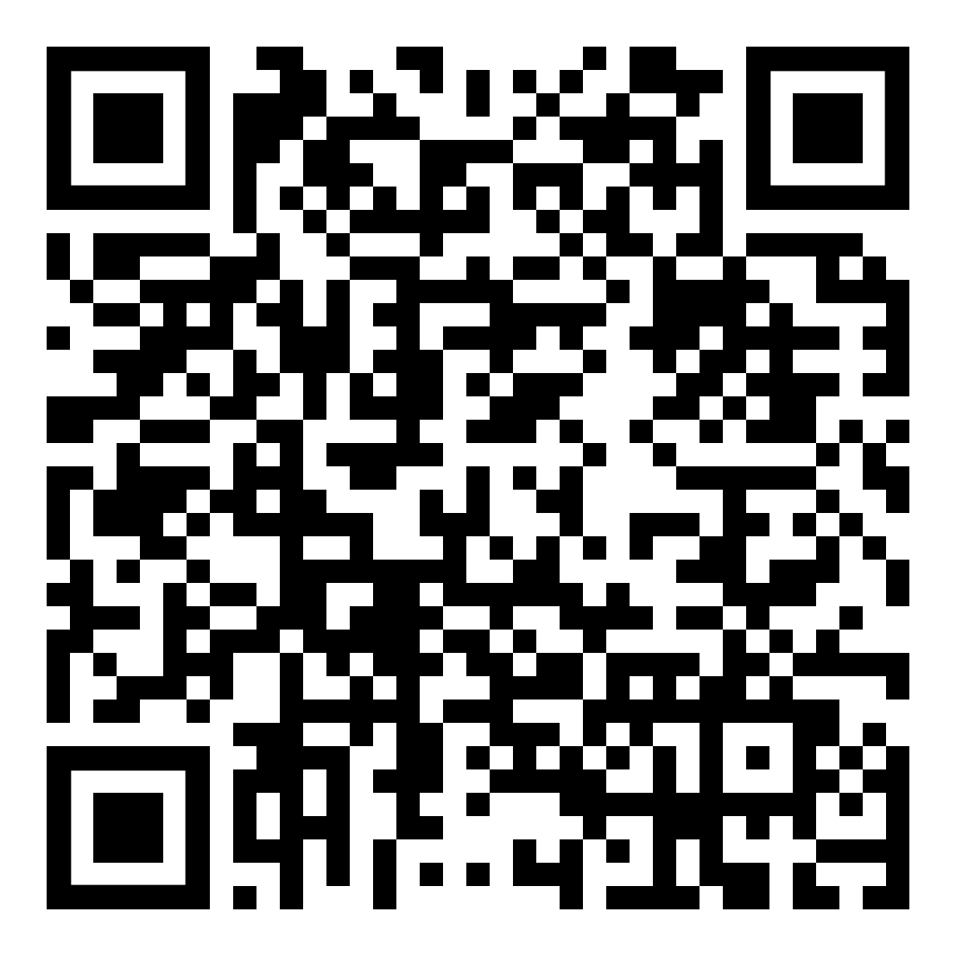
  Saturday, June 14th (Farm), 10:00am-12:00pm or 12:00pm-2:00pm
  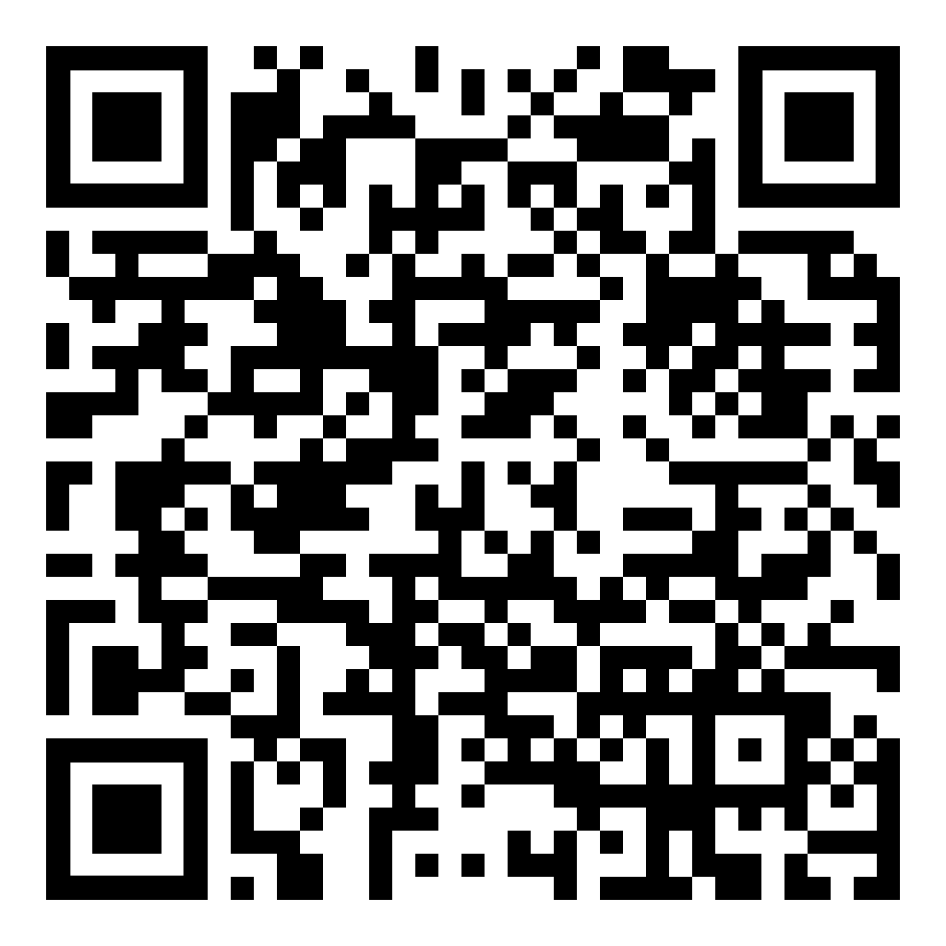
  DFM in the Community Webpage
  