Systems Improvement/Collaborative Case Review Conference Workbook

Step 1: Identify a Case
- Possible sources:
  - Word of mouth
  - RL reports
  - Safety events
  - Mortalities

Step 2: Identify the Adverse Event, Errors, Harm Score

What was the adverse event?

What was the level of harm to the patient?

What domains of potential errors contributed?

Step 2b: Report the case through the local safety reporting mechanism (if not already done)

Step 3: Analyze the Case

Create a Cause & Effect Analysis (Fishbone Diagram)

Step 4: Involve the Stakeholders

Who do you need to talk to get a full picture of the event?
- Review the chart for ALL involved providers

Who do you need to notify that the conference is being held?
- For trainees, notify their program leadership
- For nursing staff, notify their unit/clinic managers

Step 6: Identify Action Items

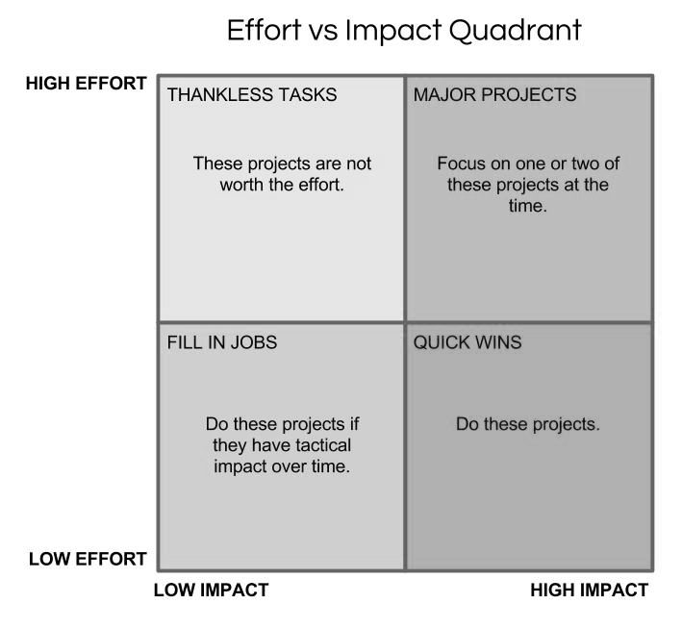

Which patient safety concerns are actionable?

Who is your support team?

How can you align these action items with organization priorities at the hospital?

Step 7: After conference debrief

What went well?

What could have gone better?

What (if anything) will you do differently next time?

What action items (no more than three) are most actionable and align?

