Run charts are simple displays of data that improve your ability to analyze and communicate your data. Run charts allow you to:
- Visualize the performance of your process
- Determine whether changes you made to your process resulted in an improvement
- Determine whether improvements introduced to your process are sustained
Constructing a Run Chart
- After choosing the question your Run Chart will answer, choose an appropriate time interval for the horizontal axis and scale for the vertical axis. A well-designed Run Chart is easy to read and gives insights into the data just based on visual inspection.
- Plot your data points on your pre-determined axes.
- Add a line representing the median of your data.
- Add labels, title, and (if desired) a line for your aim or goal.
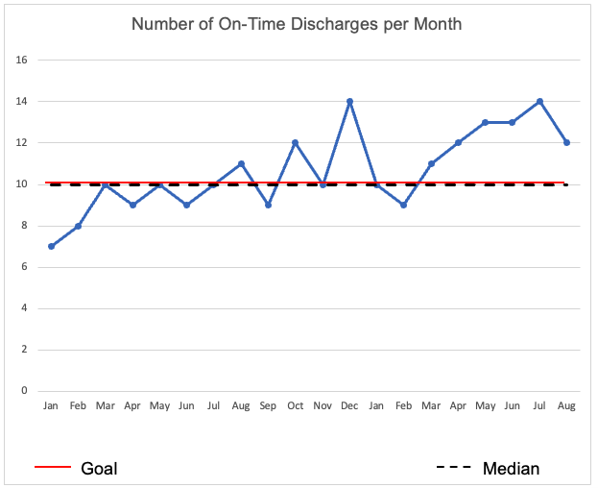

Signals of Non-Random (Meaningful) Change
These tests of the data in a Run Chart can aid in interpreting whether a non-random change has occurred in your data if it is not obvious upon initial visual inspection.
Probability of <5% (p=0.05) of occurring by chance | Aids in visual inspection and interpretation, not based on statistical probabilities
Shifts  Six or more consecutive points all above or all below the median (p = 0.03 for 6 points).  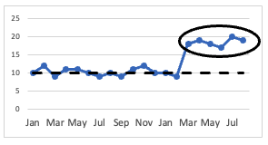 | Trends  Five or more consecutive points all increasing or decreasing.  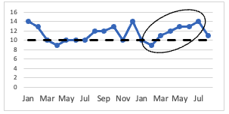
Runs  A run is a series of points on one side of the median. The trendline must cross the median before a new run begins. You can quickly calculate the number of runs by counting the number of times the trendline crosses the median and adding one.  The number of runs in a series should be between a lower and upper limit determined by the number of data points in the data set. Any more, or any fewer, and the series is likely to be non-random. See next page for a reference table on upper and lower limits.  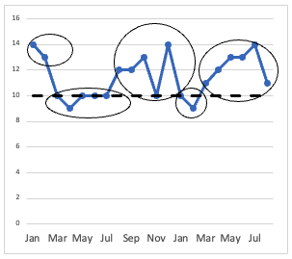 | Astronomical Data Points  Data points that are obviously outside of normal variation. As a general rule, seek consensus from the team to determine whether a point is “astronomical” or just the high or low point in the data set.  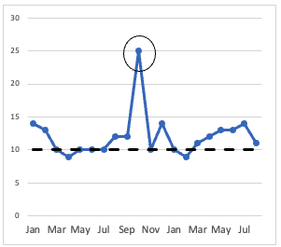
Total Number of Data Points on Run Chart Not Falling on Median | Lower Limit of Number of Runs | Upper Limit for Number of Runs
10 | 3 | 9
11 | 3 | 10
12 | 3 | 11
13 | 4 | 11
14 | 4 | 12
15 | 5 | 12
16 | 5 | 13
17 | 5 | 13
18 | 6 | 14
19 | 6 | 15
20 | 6 | 16
21 | 7 | 16
22 | 7 | 17
23 | 7 | 17
24 | 8 | 18
25 | 8 | 18
26 | 9 | 19
27 | 10 | 19
28 | 10 | 20
29 | 10 | 20
30 | 11 | 21
31 | 11 | 22
32 | 11 | 23
33 | 12 | 23
34 | 12 | 24
35 | 12 | 24
36 | 13 | 25
37 | 13 | 25
38 | 14 | 26
39 | 14 | 26
40 | 15 | 27
41 | 15 | 27
42 | 16 | 28
43 | 16 | 28
44 | 17 | 29
45 | 17 | 30
46 | 17 | 31
47 | 18 | 31
48 | 18 | 32
49 | 19 | 32
50 | 19 | 33
51 | 20 | 33
52 | 20 | 34
53 | 21 | 34
54 | 21 | 35
55 | 22 | 35
56 | 22 | 36
57 | 23 | 36
58 | 23 | 37
59 | 24 | 38
60 | 24 | 38

