Problem Statement
Your Problem Statement captures the issue you are planning to tackle and proves to your audience that you have a problem, using data. This should be a simple sentence that captures WHAT is your Problem, followed by data to prove it.

Examples:
- Over-sedation of patients in the ICU increases mortality by 25%, leading to 30 additional deaths per year.
- Inappropriate use of physical therapy consultation wastes 10,000 hours of therapist time each year.
- We only use the Pulmonary Embolism Pathway 50% of the time, and when not used, mortality for patients with acute PE doubles.
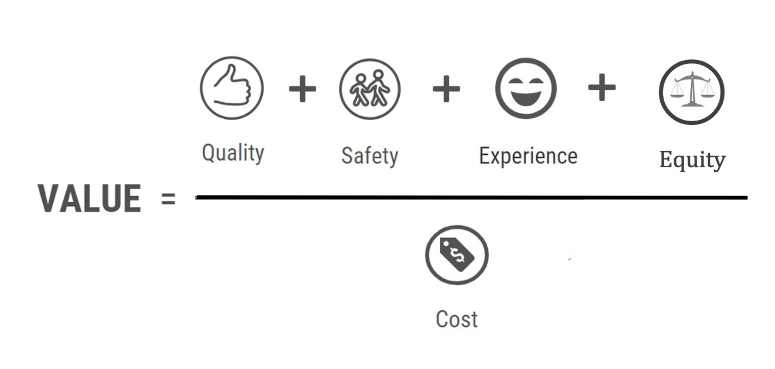
Step 1: Discuss your problem – consider the Value equation.

Step 2: Draft Problem Statement.
- An effective Problem Statement should address the following questions:
  - How do you know you have a problem?

  - Who is affected?

  - By how much?

  - Are there guidelines / best practices / standards that you are not meeting? Consider a literature search to ensure you can speak to this.

  - Include metrics, which serve as your baseline data.

Step 3: Identify missing information and a plan to acquire this data.

