**Stakeholder Analysis**

A stakeholder analysis is a process of understanding which people may influence your work or be impacted by it.  It will ensure that you are engaging the correct people early (investigate phase) as you understand your problem and later (eQuip phase) as you manage the change around your project.

* Step 1: Make a list of all the groups and key individuals who may have a perspective on the problem you are tackling or are impacted by it. This can include patients and families, providers, staff, administrative team members, and the executive leadership.
* Step 2: Determine where your stakeholders are on the power:interest grid
  + Place stakeholders from above on the grid
* Step 3: Determine degree of engagement (see stakeholder engagement plan, below).

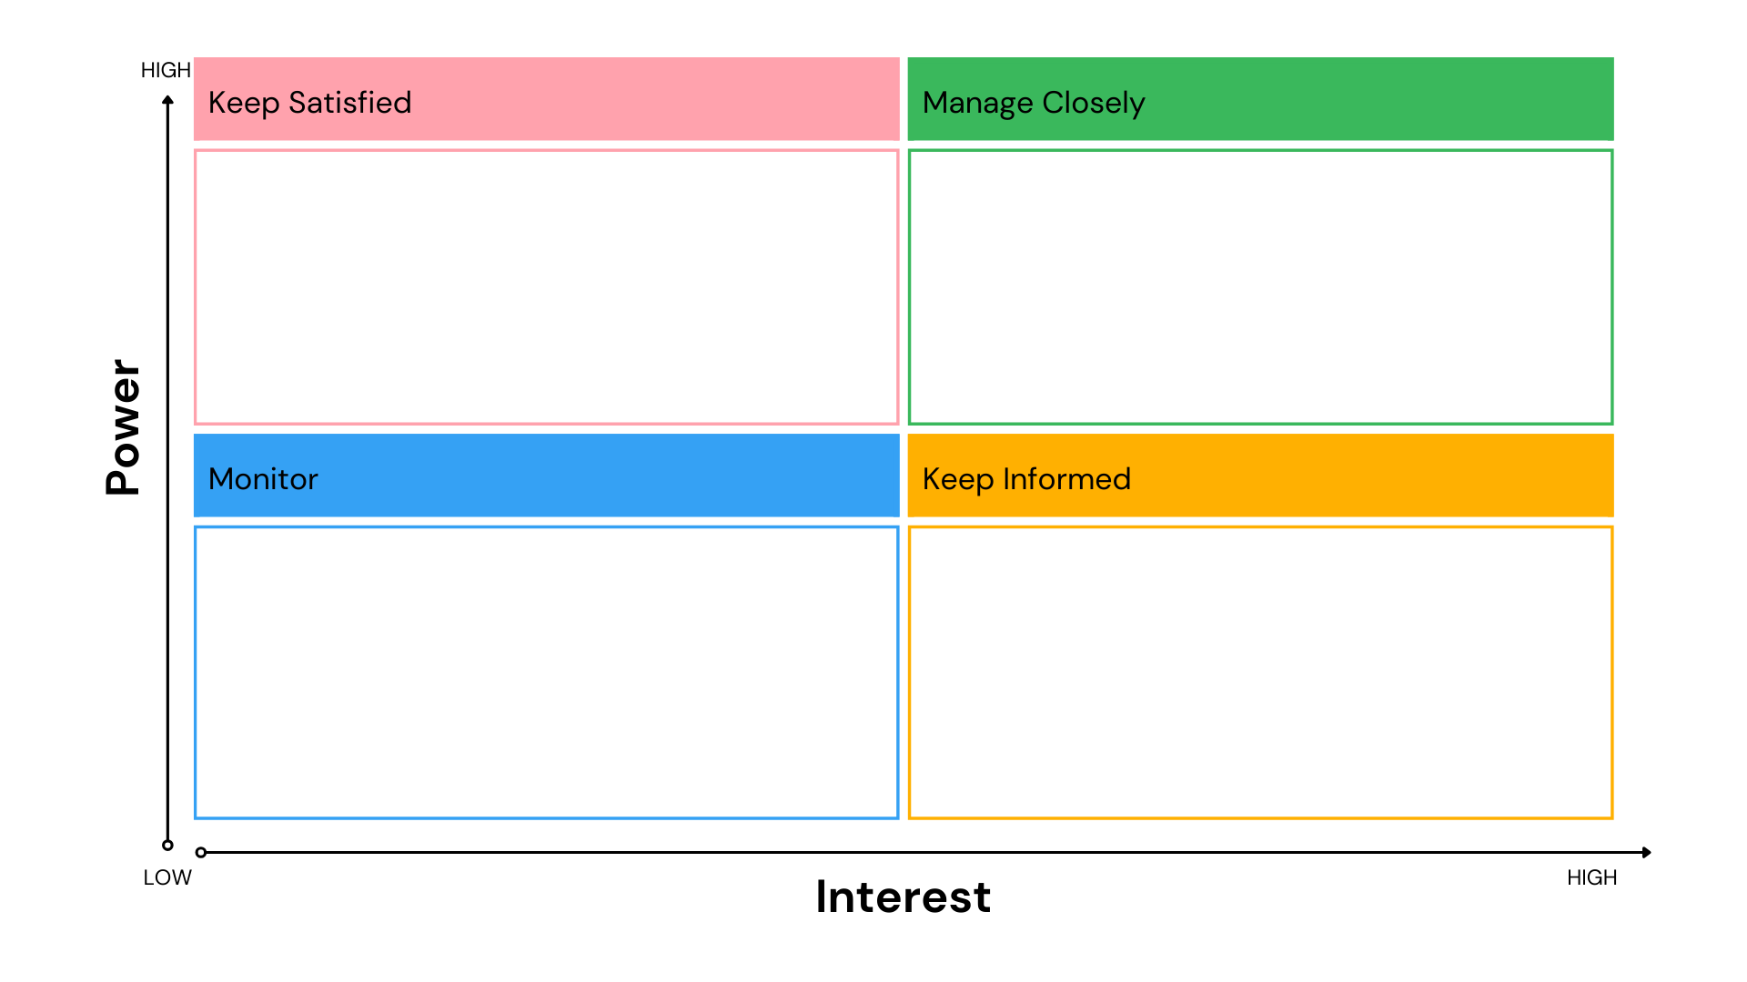

**Stakeholder Engagement Plan**

|  |  |  |  |  |
| --- | --- | --- | --- | --- |
| **Stakeholder** | **Cadence of Engagement** | **Purpose** | **Modality** | **Team Owner** |
|  |  |  |  |  |
|  |  |  |  |  |
|  |  |  |  |  |
|  |  |  |  |  |
|  |  |  |  |  |
|  |  |  |  |  |
|  |  |  |  |  |
|  |  |  |  |  |
|  |  |  |  |  |
|  |  |  |  |  |

