Choose the Most Impactful: Effort/Impact Matrix

Once you have considered the Hierarchy of Interventions, Engaged in a Design Thinking exercise, and connected with your Positive Deviants, you likely have multiple ideas for solutions. What will you implement first?

Consider the Effort / Impact concept – how can you maximize impact while minimizing effort?
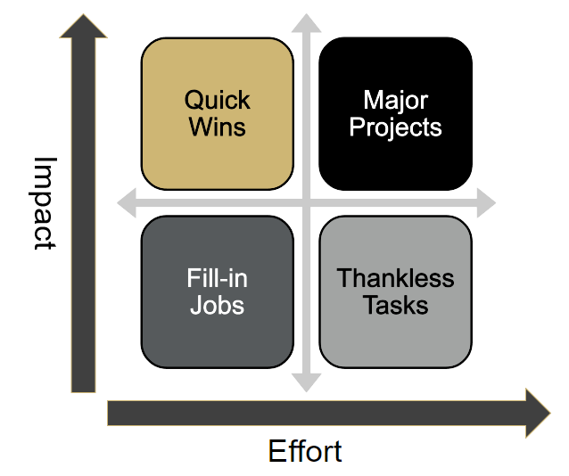

- Step 1: Do you have any Quick Wins?
These are ideas that can be implemented quickly, with minimal resources. If so, do it!
  - Examples of Quick Wins:
- A simple change to an order set that already exists
- Adding a low energy task to a role that already exists and is well integrated
- Removing wasted steps / tasks
- List ideas on the matrix above.

- Step 2: Consider higher effort ideas, that will have considerable impact.
These may include changes to the EHR, creating a new unit or team, or significantly restructuring a process. Focus most of your energy on these ideas, knowing you will need to approach Change Management thoughtfully and systematically.
- List ideas on the matrix above.

