**Affinity Diagram**

After you have completed the early steps of the Investigate phase, you will likely have many insights into what is causing your problem. Now you want to capture all the factors that contribute (aka ‘contributing factors’) to your problem in a visual tool and allow for the team to vote on which factors are most important.

* **Step 1: Brainstorm what the contributing factors are to the problem.**
  + This is usually a group event that includes 3-8 people. Fewer than that and you are likely going to miss important insights. More than that will tilt toward chaos.
  + Be sure you include multiple disciplines. If your problem includes a certain group, e.g., physicians, you should have at least one involved otherwise you are left to speculate what they think.
  + Brainstorm all the factors that may contribute to your problem. Be sure to include things you learned from your voice of the customer, stakeholder interviews, surveys, and process mapping.
  + Put each on a sticky note, or list below.
* **Step 2: Ask ‘Why’ for any factor that requires further exploration.** 
  + If you have any additional insights, put these on more sticky notes, or list below.

**Affinity Diagram**

* **Step 3: Sort your Sticky Notes into themes, or affinity groups.** 
  + These themes can encompass anything that is pertinent for your project work, but suggested themes include: Communication, Process, People, Materials, Technology, EHR, Policy, Environment.
  + What themes will you use?
* **Step 4: With your team, vote on which of the themes contributes MOST to the problem.**
  + There are many ways to do this, but one way is to allow everyone to place 3 votes for the theme they think is most important.
  + Then add up the votes and the theme with the most is your primary theme.
  + Which 1 or 2 themes received the top votes?
* **Step 5: Use this primary theme to guide your interventions.**
  + You should target this theme first, since it is causing MOST of the problem. We will discuss this more in the intervention phase of project work.
  + List any early ideas that you want to capture from your brainstorming session.

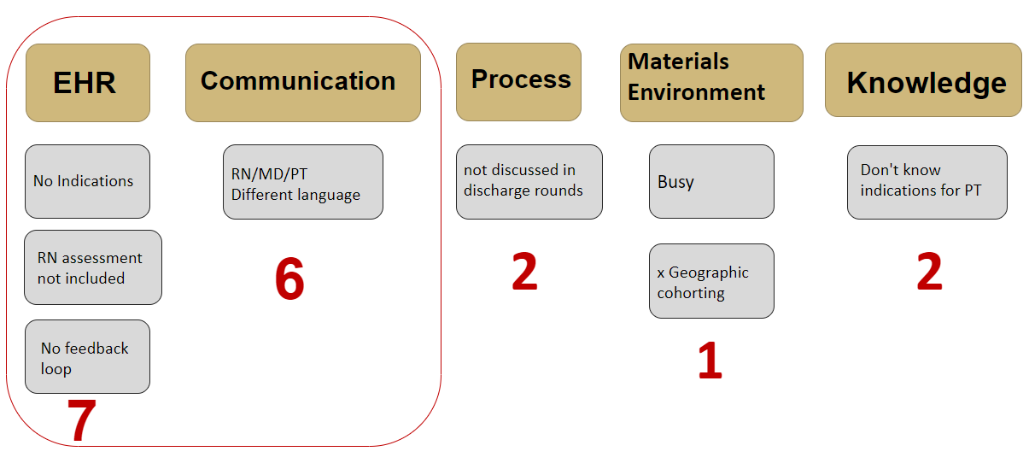**Affinity Diagram Example**