**Problem Statement**

Your Problem Statement captures the issue you are planning to tackle and proves to your audience that you have a problem, using data. This should be a simple sentence that captures WHAT is your Problem, followed by data to prove it.

Examples:

* Over-sedation of patients in the ICU increases mortality by 25%, leading to 30 additional deaths per year.
* Inappropriate use of physical therapy consultation wastes 10,000 hours of therapist time each year.
* We only use the Pulmonary Embolism Pathway 50% of the time, and when not used, mortality for patients with acute PE doubles.

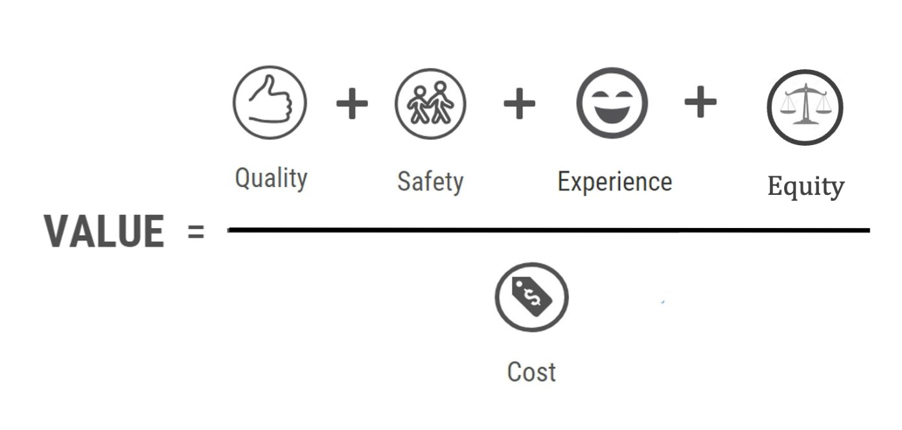  
**Step 1: Discuss your problem – consider the Value equation.**

**Step 2: Draft Problem Statement.**

* An effective Problem Statement should address the following questions:
  + How do you know you have a problem?
  + Who is affected?
  + By how much?
  + Are there guidelines / best practices / standards that you are not meeting? Consider a literature search to ensure you can speak to this.
  + Include metrics, which serve as your baseline data.

**Step 3: Identify missing information and a plan to acquire this data.**