**Step 1: Understanding your Organizational Structure**

Review the current state.

* + Review Division of Hospital Medicine organizational chart
  + Review the institutional quality and safety organizational chart
  + Review the executive leadership organizational chart

Ask the following questions:

1. Where is case review currently happening within your organization?
   * Where does your work fit into this?
2. Where will your diagnostic excellence program fit within your organization? (solid versus dotted lines)
3. When we find improvement opportunities, who will be responsible and resourced to fix them? If it’s not apparent, what would be a good idea?
4. Where would you go when you need resources (data, people, money)?

**Step 2: Stakeholder Map**

Stakeholder list: CQO, CMO, Division Chief, QI Director, Safety Director, Internal Medicine Residency Program Director/Chief Resident, Internal Medicine Residents, Hospitalists

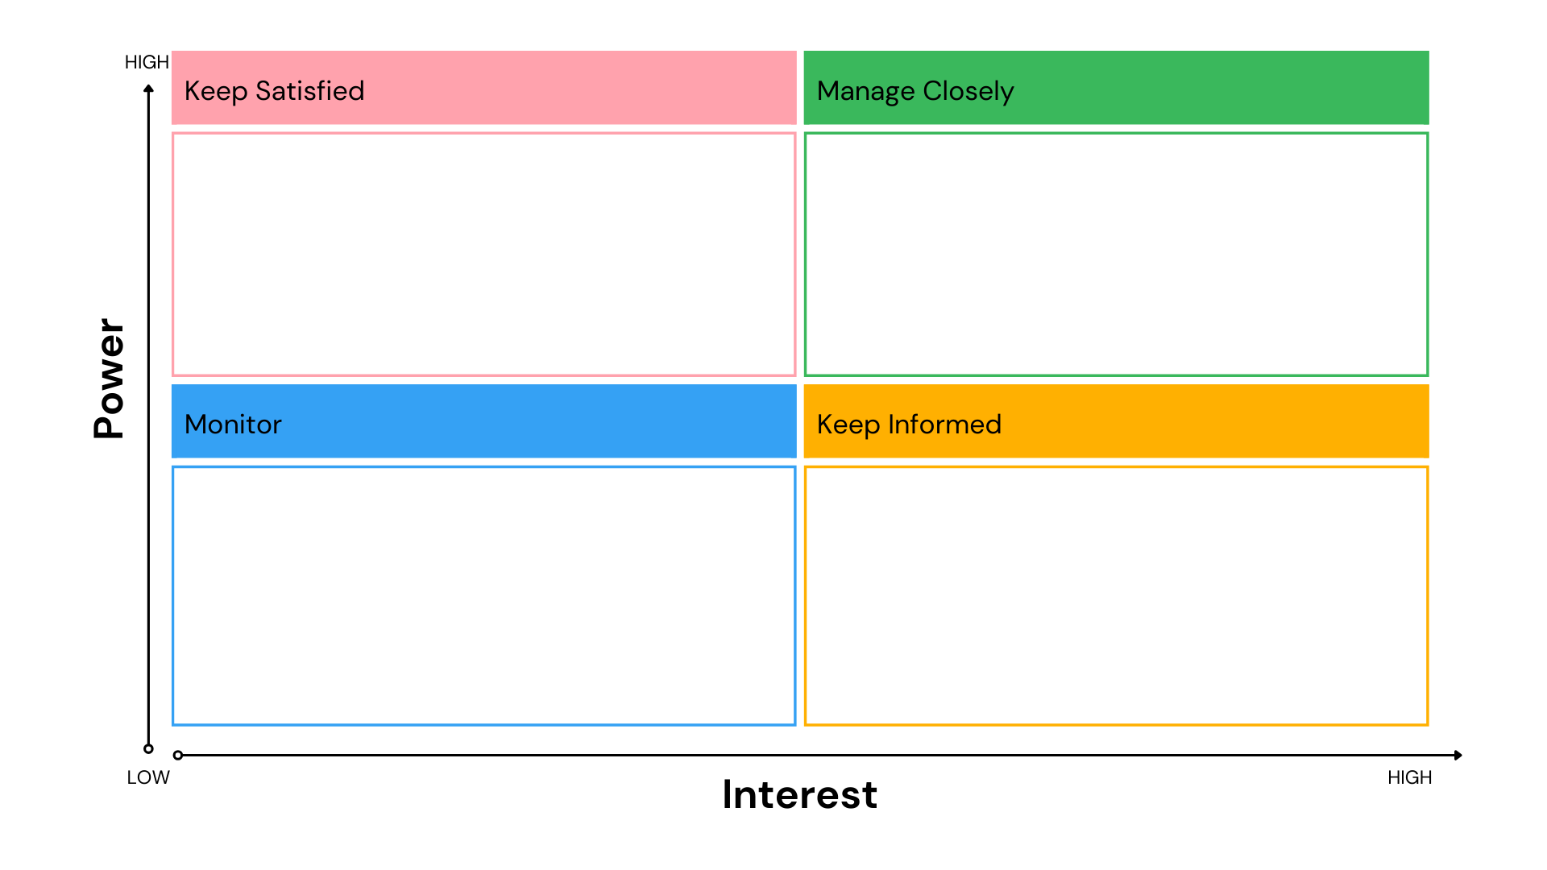

**Stakeholder Engagement Plan**

|  |  |  |  |
| --- | --- | --- | --- |
| **Stakeholder** | **Cadence of Engagement** | **Modality** | **Team Owner** |
|  |  |  |  |
|  |  |  |  |
|  |  |  |  |
|  |  |  |  |
|  |  |  |  |
|  |  |  |  |
|  |  |  |  |
|  |  |  |  |
|  |  |  |  |
|  |  |  |  |

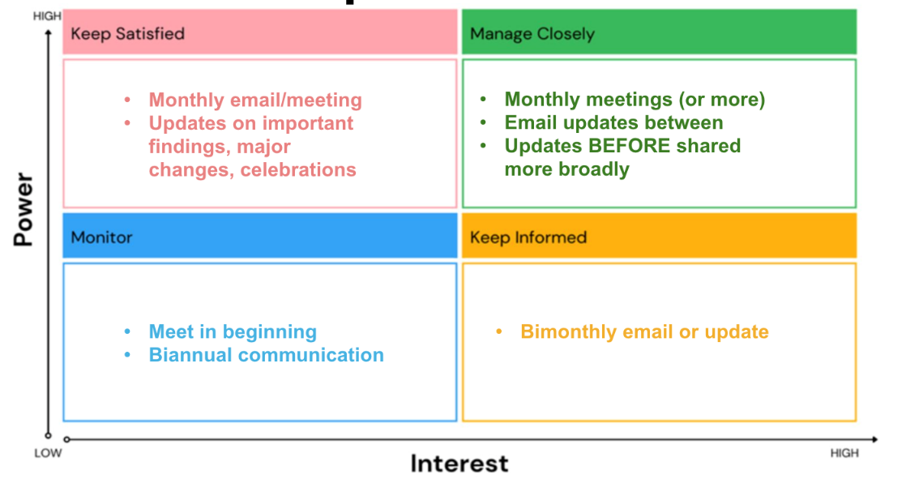

**Step 3: Voice of the Customer**

The leaders that you should engage include: CMO, CQO, Division chair +/- Dept chair, Division QI/safety leadership, internal medicine residency leadership, hospitalists, residents.

* Review list of stakeholders (individuals or groups) that you need input from.
  1. Put meetings on the calendar for each one.
  2. Plan your approach to the conversation—what will you ask to uncover motivations, perspectives, or needs?
     1. See website for a sample list of discussion questions.
* Survey
  1. Identify the key steps to administering your survey
     1. First meeting for those managing the survey
     2. Deadline for developing the questions
     3. Launch survey
     4. Collate the findings
     5. Share the findings

|  |  |  |  |
| --- | --- | --- | --- |
| **Customer** | **Motivations Query** | **Perspectives Query** | **Meeting Preparation** |
| **1.** |  |  |  |
| **2.** |  |  |  |
| **3.** |  |  |  |
| **4.** |  |  |  |
| **5.** |  |  |  |
| **6.** |  |  |  |
| **7.** |  |  |  |
| **8.** |  |  |  |

**Step 4: Identify your Guiding Coalition (aka your Diagnostic Excellence Program Team)**

* Name your current or future team members for a Diagnostic Excellence Programmatic Leadership Team. This is a group developing and executing your Diagnostic Excellence Program (of which, case review is a subgroup of the effort, along with things like education, research, etc.).
* What unique experience/expertise do they bring?
* Who will lead this work? This may or may not be your current site lead. This also may or may not be your decision as you may need to consult with Division Chief or other leadership.
* Plan the frequency of your meetings with this guiding coalition
  + In general, you should be meeting at least monthly
  + If you have pre-identified subgroups (research, education), plan those as well

|  |  |  |
| --- | --- | --- |
| **Team member** | **Roles** | **Expertise / Influence** |
|  |  |  |
|  |  |  |
|  |  |  |
|  |  |  |
|  |  |  |
|  |  |  |
|  |  |  |
|  |  |  |
|  |  |  |
|  |  |  |

**Executive sponsors:**

**Programmatic lead:**

**Cadence of meeting frequency:**