# **Appreciation: Individual, Team/Group, Systems, and Safety II**

**Create an individual appreciation email using the Appreciation Formula:**

* Identify 3-5 behaviors you want to reinforce in your DxEx work.

* Craft a draft email appreciation statement using the formula.

Thank you to {person/people - names},        *Personalize it!*

For {description of behavior/act} *Reinforce ideal behaviors*

Because {*here’s how it impacted me*}          *Connect behavior & outcome*

* Share your draft email for feedback with a peer.

**Create a Group/Team approach for capturing and regularly sharing appreciation**

* Create a mechanism to capture opportunities and support planned & deliberate appreciation (avoid “waiting for random chances”).

|  |  |  |  |  |  |
| --- | --- | --- | --- | --- | --- |
| **Type of positive DxEx behavior to reinforce** | **Who demonstrated?** | **What enabled the behavior?** | **What was the impact?** | **How to get more of that?** | **Public vs. Individual recognition?** |
|  |  |  |  |  |  |
|  |  |  |  |  |  |
|  |  |  |  |  |  |
|  |  |  |  |  |  |

* Create a templated approach to public recognition (email). Craft a draft email appreciation statement using the formula

Thank you to {person/people - names},        *Personalize it!*

For {description of behavior/act} *Reinforce ideal behaviors*

Because {*here’s how it impacted me*}          *Connect behavior & outcome*

* Write a draft paragraph at the end to prompt others to send you these sorts of public recognition.

**Where can you weave appreciation into other public displays that people will see regularly?** *Consider multi-media approach (email, sharing nominations for awards with the group nominated, tracking board, in-person, group, party, social media posts).*

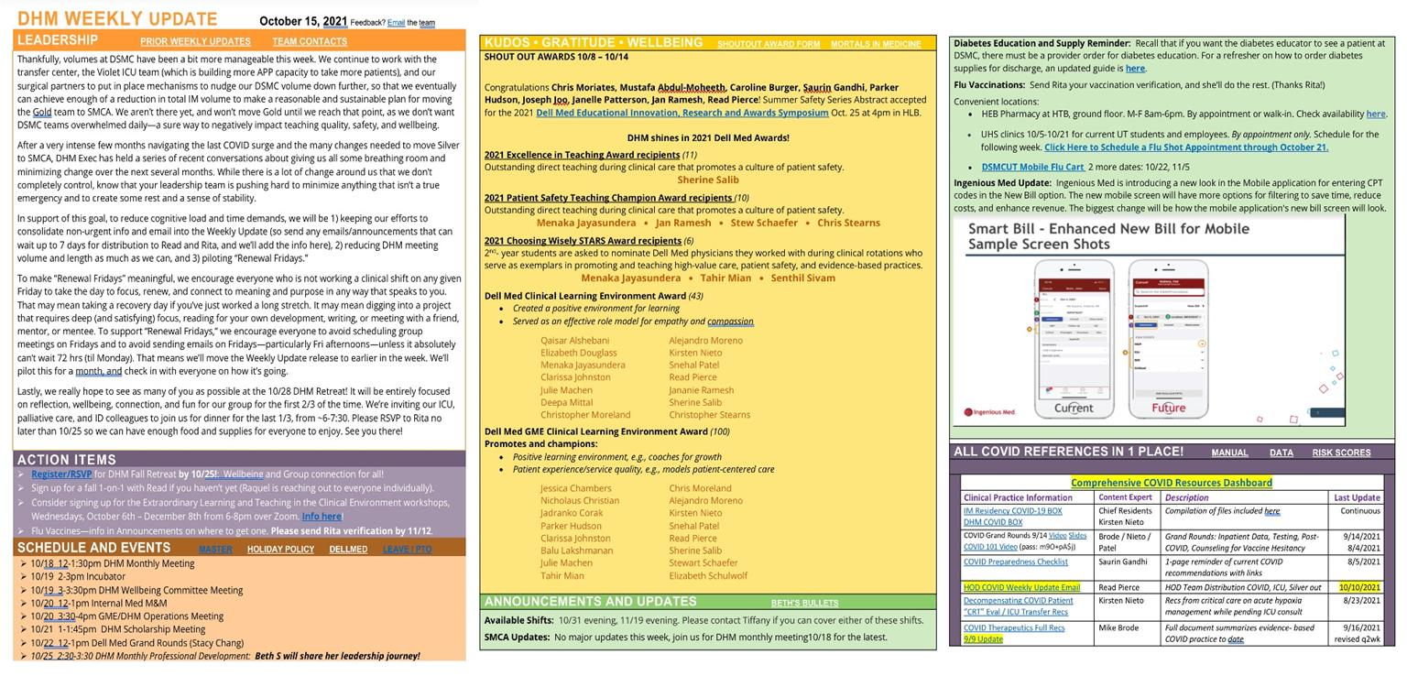**Example:**

**Where can you weave appreciative debrief into regular meetings/activities?**

**Create a symbol/photo that can be personalized and rotated regularly as a celebration of desired behaviors.**

* What symbol or photo will you use?
* How will you select who receives it?
* With what cadence will you rotate it?
* How will you encourage individuals/teams to personalize it?

**Turn a typical Case Review Conference into a Safety II Conference (focused on Appreciating What Went Well)**

* What case will you select? If you don’t have one readily identified, how will you go about finding this?
* What are your objectives for discussing this case? Think about what Safety II themes may have arisen in this circumstance.
* Who is the target population for the case sharing? Think about what case conference or forum you would utilize to share.
* What discussants or experts may you invite to the case?