Value Defined – Identify Opportunities to Enhance Value
The goal of this application is to identify opportunities where value could be enhanced in your clinical unit. These areas of opportunity will drive your project work.
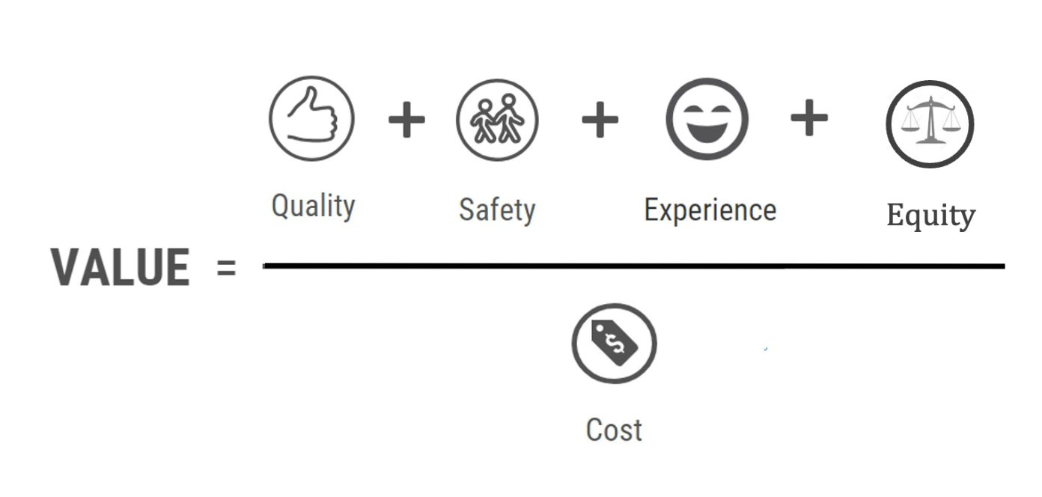
- Quality – Do you have any metrics or dashboards? Are there any high priority metrics?

- Safety – Do you track patient safety events? Are there any themes?

- Experience – Do you have access to satisfaction survey data? Are there any themes?

- Equity – Is access and outcomes similar across patient populations? How do you know?

- Cost / Waste – Where do you see inefficiencies or wasted time or resources?

