Data to Understand Your Problem

Once you have acquired data, you need to analyze that data to deeply understand your problem including identifying your current performance and revealing deeper root causes.

Pareto Charts
The Pareto Principle
The Pareto Rule officially states that “80% of a problem comes from 20% of the causes of that problem,” but in practice these quantities are an estimation. The principle that a critical sub-set of causes can be identified whose contribution to a problem outweighs that of other causes is generally true. The Pareto Principle can be used to narrow the focus of an improvement project to only the causes that contribute most to the problem to avoid inefficient use of resources.
- Using a Pareto Chart
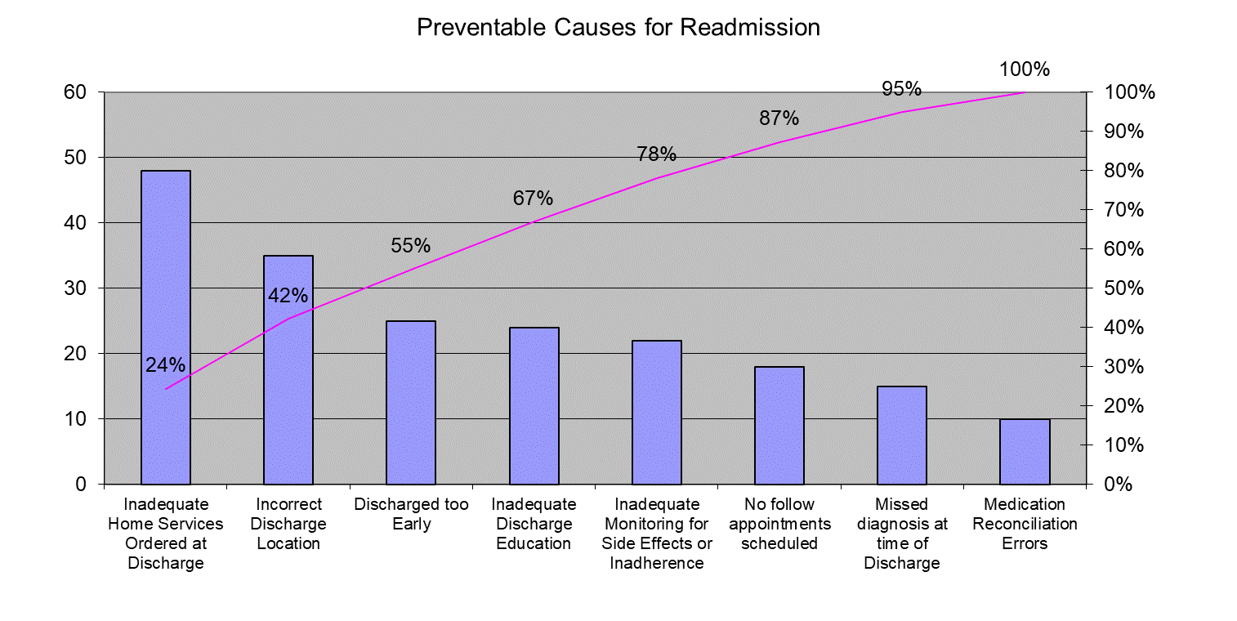
- The Pareto Rule can be represented visually by a Pareto Chart. The number of occurrences of each cause is represented by the bars, while the cumulative percentage of the contribution of these causes is represented by the line.

- One can focus improvement efforts on the causes that seem to have the highest yield for improvement. In this example, the team might consider putting resources into improving discharge planning to ensure patients are being discharged to the right location and receiving the right equipment when discharged home, which will probably reduce readmissions more substantially than improving the medication reconciliation process.

Data Over Time
Graphical tools to display data over time are the backbone of QI methodology because they allow team members to understand processes, test hypotheses and learn about intervention effectiveness.
The two most common chart types for displaying data over time are Run Charts and Statistical Process Control (SPC) Charts. These charts will be your source of information for how your processes are currently performing AND whether your interventions are happening and working.
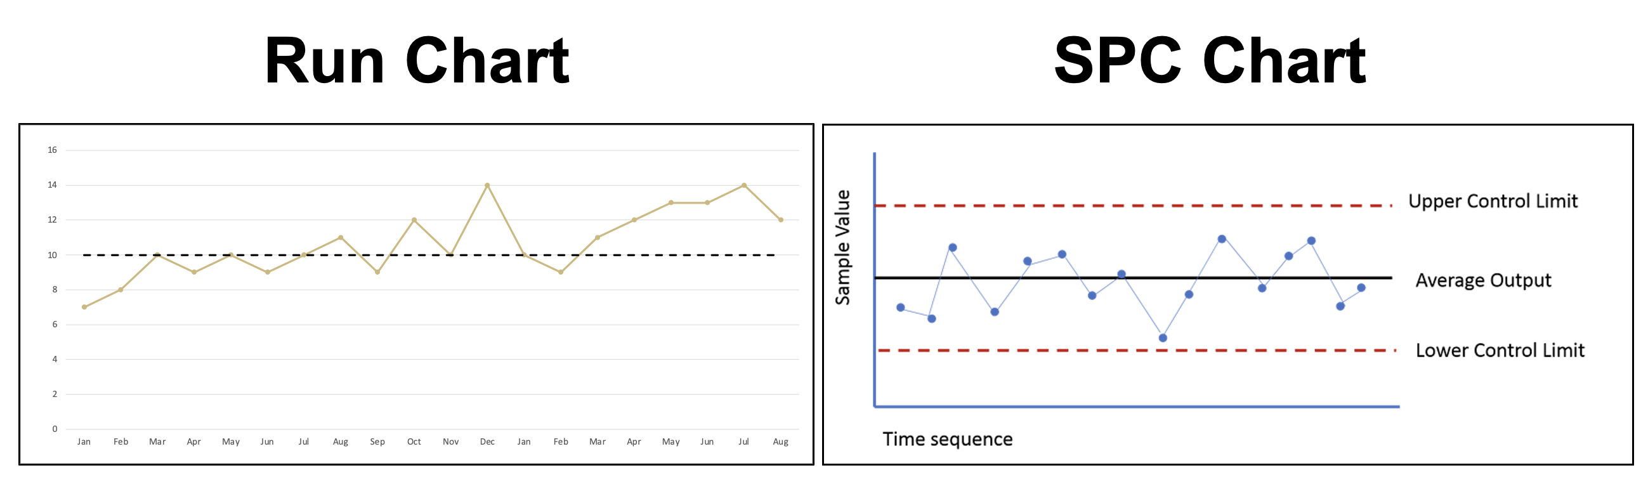
Run charts display performance over time using median as the center line. These can be constructed easily.
SPC charts display performance over time using mean as the center line and with upper and lower control limits. These charts give you more information about data consistency and variability. These require more advanced training to construct.
Step 1: Using your Process and Outcome measures, determine which you will track over time.

Step 2: Determine what type of chart will meet your needs.

Step 3: Once plotted, identify whether you are currently performing consistently (but not at goal) or inconsistently. You will use this information to determine what type intervention you want to start with.
- If you are consistent, but not at goal consider overhauling the whole system.

- If you inconsistent identify what you do when you are meeting your goals and tweak the system to do that more consistently.
  - NOTE: If you don’t ever meet your goal/target performance (even briefly), look at what gets you the closest. You may still need to overhaul the system.

