Time Management & Delegation

Step 1: Get More Time

- How much more time (in FTE) do you feel you need? ______

- List people you could engage in supporting your work (even if you can’t pay them).

Step 2: Free up time
- Review your calendar for the next two weeks. Make a list of all the meetings and non-clinical work (tasks like writing papers, building presentations, doing a QI project) that you need to complete. If you are largely clinical look at the next two weeks that you are mostly non-clinical/administrative.

- Which meetings could you cut? Keep a high bar for what is absolutely necessary. Recurring meetings are often opportunities to reduce meeting time. The goal is to cut 10-20% of all meetings.

- Which meetings could you reduce the amount of time. Work to decrease remaining meeting time from 60 to 30 minutes (or 15 minutes). Very few meetings need an hour. Most can be done in 15-30 minutes.

- Add up the numbers of hours you save in fewer and shorter meetings per week.
  - Hours saved each week ______

Step 3: Delegation
- Review your list of work for the next 2 weeks. Label each as work ONLY you can do and work that could be done by others. For most people, at least 50% of the things they do could be done by others. Don’t worry if you don’t have someone to delegate it to. Just come up with the items you could delegate.

Work | Can others do this or only you?
Only me
Others
Only me
Others
Only me
Others
Only me
Others
Only me
Others
Only me
Others
Only me
Others

- Make a list of the people who report to you, those adjacent to you, colleagues who may be interested in being involved in the work you do.

- In the table above, match tasks to someone who you could delegate to.

- For tasks that don’t have a delegee, who can you develop for the future to do these kinds of tasks?

- Add up the number of hours you save by better delegation.

  - Hours saved each week ______

Step 4: Better Allocate your Time
- Review your list of work for the next 2 weeks.
- Add items that you need to get done but are not on your schedule.
- Label each task as urgent/non-urgent and important/not important.
- Place your tasks in the Eisenhower Matrix

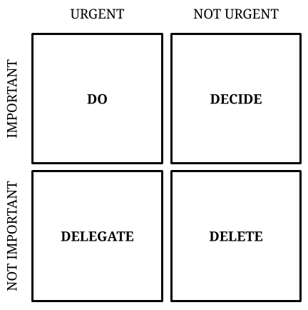

Step 5: Schedule Your Time
- Review your schedule for the next two weeks.
  - How many unscheduled hours to you have between normal business hours?
  - Unscheduled hours each week ______

- Review your list of meetings (Step 4) and add any tasks that you have to complete that’s not on the list. Add work you need to do that doesn’t require meetings (e.g., paper, talk, research, prep for a big meeting).

- Add all your meetings into your calendar.

- Add all items you have to do that aren’t meetings, into your calendar.
  - Include breaks, lunch, kids' soccer game, read and overlook your accounts.

- Make sure all hours are filled, every day—you can put in ‘creative time.’

- Pro Tips
  - For tasks, put in more time than needed so you can feel good about being ahead.
  - Use extra time (from getting done early) to do things that you enjoy (e.g., walk, read).
  - Cross completed tasks off your ‘to do’ list to create positive emotion.
  - Schedule your email and do NOT look at email unless it’s during that session.
  - Schedule fun stuff into your day (kids’ soccer, exercise, etc.).
  - Accountability—Can’t end my day/eat lunch until I’m done with work. BUT, can end when I’m done.

