Quality Ops Guide
Purpose: RAE practice facilitators on behalf of their PCMPs are requesting more detailed information from HCPF about how supplemental and EHR data feeds/elements flow into and thus contribute to calculating clinical quality measures. Specifically:

- Data flow & data sources: How data moves from source → to HCPF → into measure calculation
  - EHR Data
    - In order to report EHR supplemental data to HCPF, PCMPs must have an EHR for electronic reporting, and those PCMPs' EHRs must be connected to an HIE (Contexture or Carina)
    - Manual reporters will not have their data included in supplemental data as the level of detail is not sufficient to include. A non-FQHC PCMP must have an electronic connection to Contexture for their supplemental data to be captured. FQHCs have their own process with Carina to get supplemental data captured.
  - Supplemental data(s):
    - CIIS Registry data
    - Clinical/ EHR data
    - Laboratory data
    - Vital Records data from the Colorado Department of Public Health and the Environment (CDPHE)
    - DOC data files

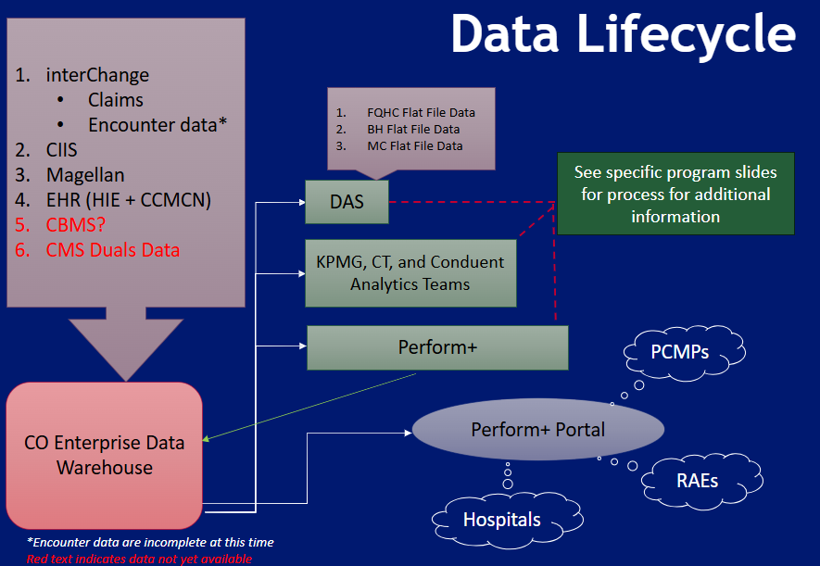
Notes for Data lifecycle graphic: 1) Encounter data comes from MCOs & is not fully complete in our system at this time 2) CBMS and CMS duals data continue to be a work in progress.

Key Question for Response:
- For each measure, what specific data elements does HCPF use and where does each one come from?
Please refer to the CMS Core Measure specifications to find more detailed information about each measure. Each measure has a value set directory that can provide further information on what goes into the measure calculation. Measures that include Laboratory Data will have this as one of the data sources. Immunization measures will include CIIS Registry Data.
- Calculation logic & algorithms: “Decision making factors”
  - The algorithm used to calculate measures (not measure specifications)
    - HCPF uses a HEDIS certified tool to calculate all CMS Core Measures. The RAEs also have their own HEDIS certified tools for calculating measures. The algorithm used by the HEDIS certified tool to calculate measure performance is proprietary.
  - How HCPF handles multiple data sources for the same patient and same measure
    - The data sources work together and a patient will only be captured in the numerator one time per measure.
  - What happens when there is conflicting information
    - There will not be conflicting information as the data sources work together to give an accurate/full picture of a numerator qualifying event for a member.
  - What takes precedence when data elements disagree
    - Data sources work together to give a full picture of measure performance. Data elements should not be in disagreement. A member will be captured in the numerator one time per measure they qualify for.
Example questions from RAEs:
- When two sources conflict (e.g., CPT II vs lab data), what logic determines which one is used?
  - It is unlikely that two sources will conflict, but rather one might be more precise than another. Lab data is more precise than CPT II codes because it is a clinical value where a CPT II code is a proxy value. Thus, if lab data is available then it will take precedence over a CPT II code.
  - How is numerator inclusion determined?
    - This will be dependent on measure specifications and the measure.
  - Is there a hierarchy of data sources?
    - The hierarchy of data sources will depend on the measure and what is available and clinically appropriate for that measure. But as a general rule of thumb:
      - Clinical chart abstract (most reliable) → structured EHR observation (lab result/ vitals) → Procedure/ Encounter Claim (evidence of service) → CPT II / quality reporting code (proxy value)
      - If Lab and CPT II code → use lab value
      - If multiple lab results → use most recent value
      - If multiple lab results in same day → use lowest value
      - No lab value but CPT II exists → use CPT II as proxy value
- Depression screening measure: Is the PHQ-9 score pulled? Is the follow-up plan pulled from the EHR?
  - There are only 2 G-codes used in the depression screening measure. The score of the PHQ -9 might be in the patients chart but it is not included in the measure since only 2 G-codes are used to determine either a positive or negative depression screening. The specifics of the follow-up plan might be in the patients chart but again only the 2 G-codes are used so we do not see the specifics of the follow-up plan or even if the follow-up plan had follow-through.
- Depression screening measure: Is the PHQ-9 score pulled? Is the follow-up plan pulled from the EHR?
  - There are only 2 G-codes used in the depression screening measure. The score of the PHQ -9 might be in the patients chart but it is not included in the measure since only 2 G-codes are used to determine either a positive or negative depression screening. The specifics of the follow-up plan might be in the patients chart but again only the 2 G-codes are used so we do not see the specifics of the follow-up plan or even if the follow-up plan had follow-through.
Given that there are only 2 g-codes for the depression screening measure ( positive PHQ -9, or negative – per above HCPF response), and given that the CMS measure is “Numerator: Patients who received a screening for depression and a follow-up plan if the screen was positive”, how is the numerator calculated ?

- For practices not connected to Contexture or Carina?
They can use the g-code but not communicate that a plan is in place, that would seem that they aren’t able to get credit for the measure? Is that accurate, or is there something we are missing?

- For practices that are connected to Contexture or Carina, is it accurate to assume the follow up plan is able to be captured and reported?

- Glycemic Control: “If they trust that the lab data will be accurately captured, then they don’t need the additional cumbersome step of adding the CPT II code.”
  - Is the lab data sufficient on it’s own?
    - If lab data is present then it is sufficient.
  - Is CPT II required?
    - A CPT II code should be included if lab values are not present. If unsure if lab values will be present then include the CPT II code so a member is captured in the numerator.
  - If both are present, which is used?
    - If both are present then the lab value will be used as it is a precise clinical value and CPT II codes are proxy values.

