**Accreditation**

In support of improving patient care, American Academy of Addiction Psychiatry is jointly accredited by the Accreditation Council for Continuing Medical Education (ACCME), the Accreditation Council for Pharmacy Education (ACPE), the American Nurses Credentialing Center (ANCC), the American Academy of PAs (AAPA), American Psychological Association (APA) and Association for Social Work Boards (ASWB) to provide continuing education for the healthcare team.



**Interprofessional Continuing Education**

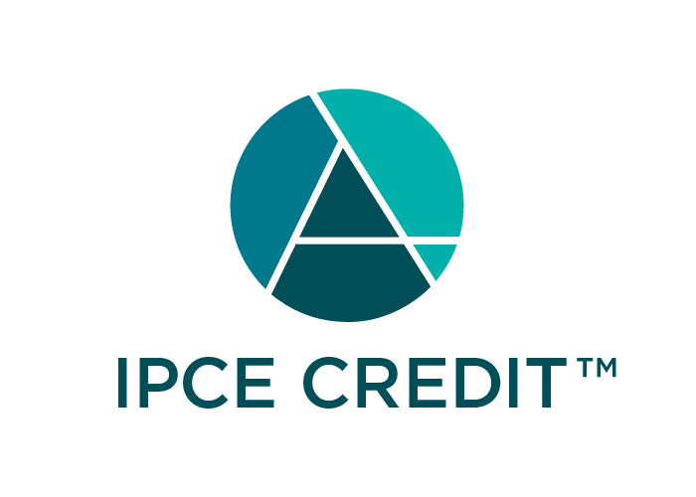

This activity was planned by and for the healthcare team, and learners will receive**4 (four*)* Interprofessional Continuing Education credits** for learning and change.

**Physician Designation**

American Academy of Addiction Psychiatry designates this enduring material for a maximum of 4 (four) *AMA PRA Category 1 Credits*™. Physicians should claim only the credit commensurate with the extent of their participation in the activity.

**Nursing Designation**

This program has been reviewed and is acceptable for up to 4 (four) Nursing Contact Hours.

**Pharmacy Designation**

This course has been approved for 4 hours of pharmacy continuing education credit. The approval numbers issued are Universal Activity Numbers JA4008192-0000-19-001-H01-P (pharmacy) and JA4008192-0000-19-001-H01-T (pharmacy tech).

**Physician Assistant Designation**

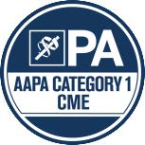

American Academy of Addiction Psychiatry has been authorized by the American Academy of PAs (AAPA) to award AAPA Category 1 CME credit for activities planned in accordance with AAPA CME Criteria. This activity is designated for 4 AAPA Category 1 CME credits. Approval is valid until 2/12/2020. PAs should only claim credit commensurate with the extent of their participation.

**Method of participation in the activity:**To be awarded a maximum of 4 AAPA Category 1 CME credits you must:

1. Review 5 training modules (4 hours) provided in this activity.
2. Earn a passing score of 75% on each of the module’s post-tests.
3. Complete a final evaluation and follow instructions at the end of the course regarding how to retrieve your Certificate of Completion as well as your continuing credit certificate*.

*\*Credit will not be awarded unless all components of the program are completed. Partial credit will not be awarded.*

**Disclosures:**

AAAP's CE program aims to provide educational information that is balanced, independent, objective and free of bias and based on evidence. In order to resolve any identified Conflicts of Interest, disclosure information from all series planners and speakers is provided during the planning process to ensure resolution of any identified conflicts. The following PCSS-MAT, CPD Committee and AAAP staff members have reported that they have no commercial relationships relevant to the content of this activity to disclose: Stephen Wyatt, DO, Sanchit Maruti, MD, Thomas Penders, MD, Michael Goedde, MD, Kevin Sevarino, MD, Nitigna Desai, MD, Kathryn Cates-Wessel, Justina Andonian, Miriam Giles, Seth Acton, Marie Samson and Erin Waters.

**Disclosure of Unlabeled Medication Use:**

Recommendations involving clinical medicine are based on evidence that is accepted within the profession of medicine as adequate justification for their indications and contraindications in the care of patients.