Meeting: CU ACC Diversity and Inclusion Meeting

Date and Time: Friday, September 24, 2021, 12:45 pm to 1:30 pm

Location: Online Zoom

Attended by:
Maribel Sandoval
Huntington Potter, PhD
Heidi Chial, PhD
John O’Shaughnessy
Polly Serrano
Michelle Stocker
Jennifer Krupa
Trevor Sooy
Erika Dallmann
Francesca Dino

Notes:
PASCO has an intake team guides each family through this process. If care giver lives in the same home, PASCO provides for activities of daily living tasks. They help by providing a support system to become CNA. They help remove barriers. PASCO was founded 1992, advocates for Medicaid for the clients they serve

Family member CNA care giver program, CNAs get paid to take care of family member.
Pediatric Personal Care

4 Programs
Parent caring for loved one – Family member as a CNA
Cerebal palsy, stroke, spinal cord injuries
Certified Nurses Assistant
School and Exam
Nursing backup & oversight

Pay for up to 2 caregivers
Son or daughter taking care of older parent
Grandparent taking care of grandchildren
Pay for nursing school

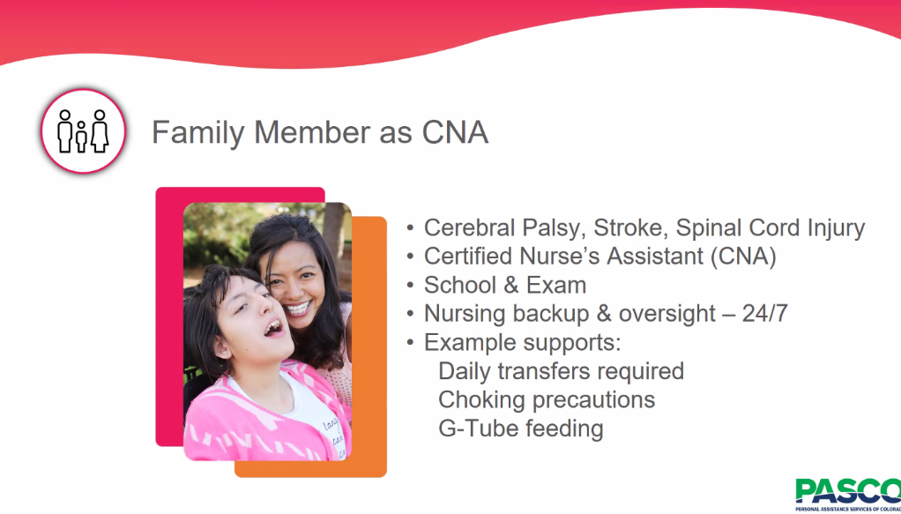

Can apply with Colorado mediciad

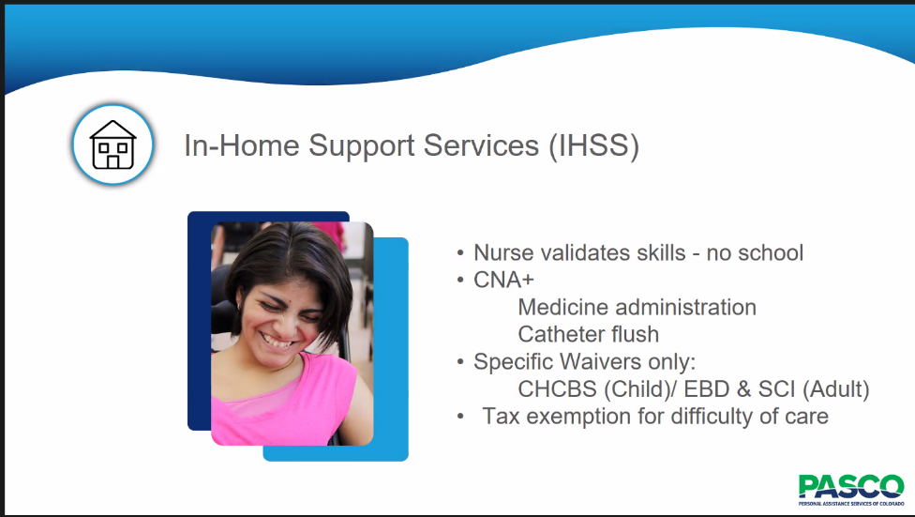

Third program
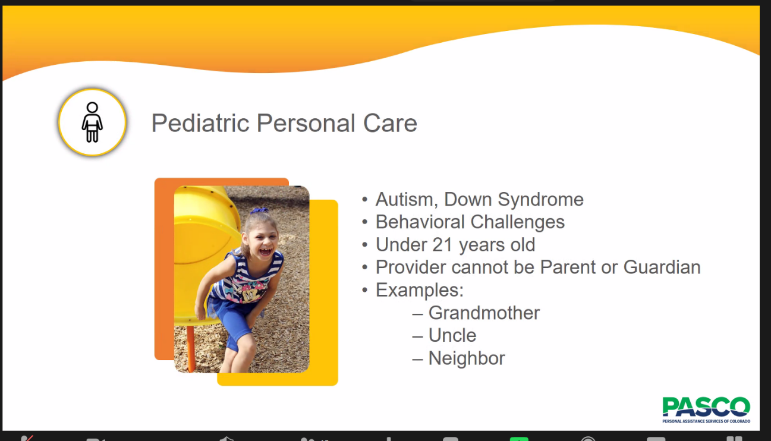

Behavioral challenges under 21, approved by medical provider

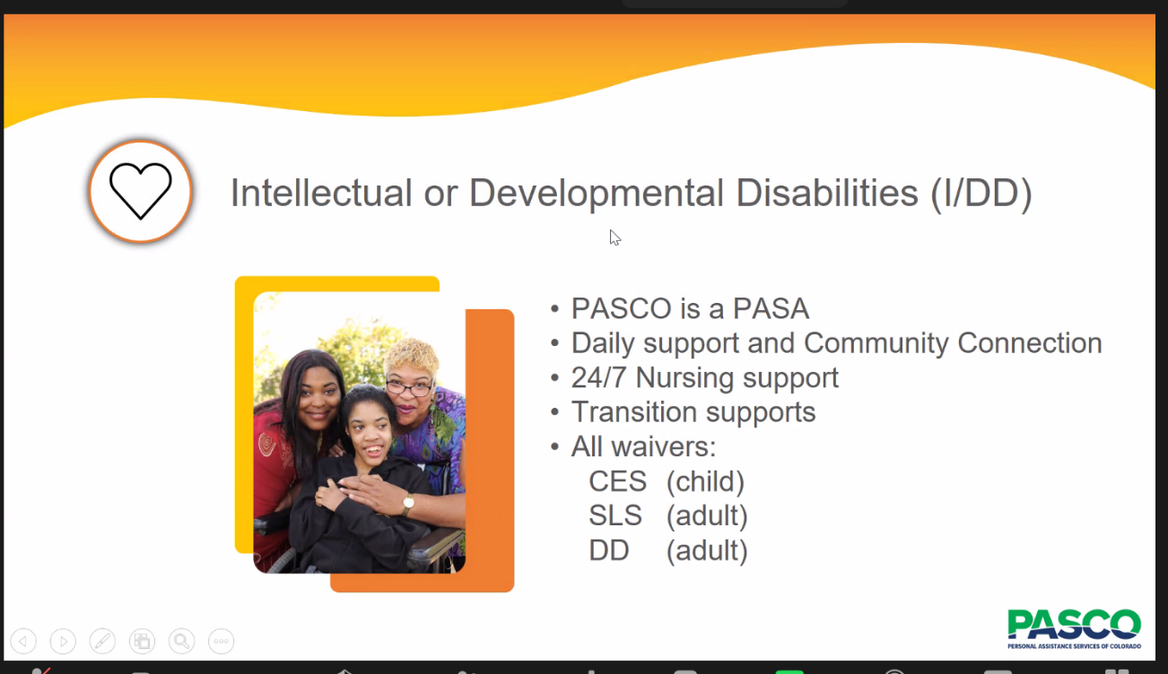

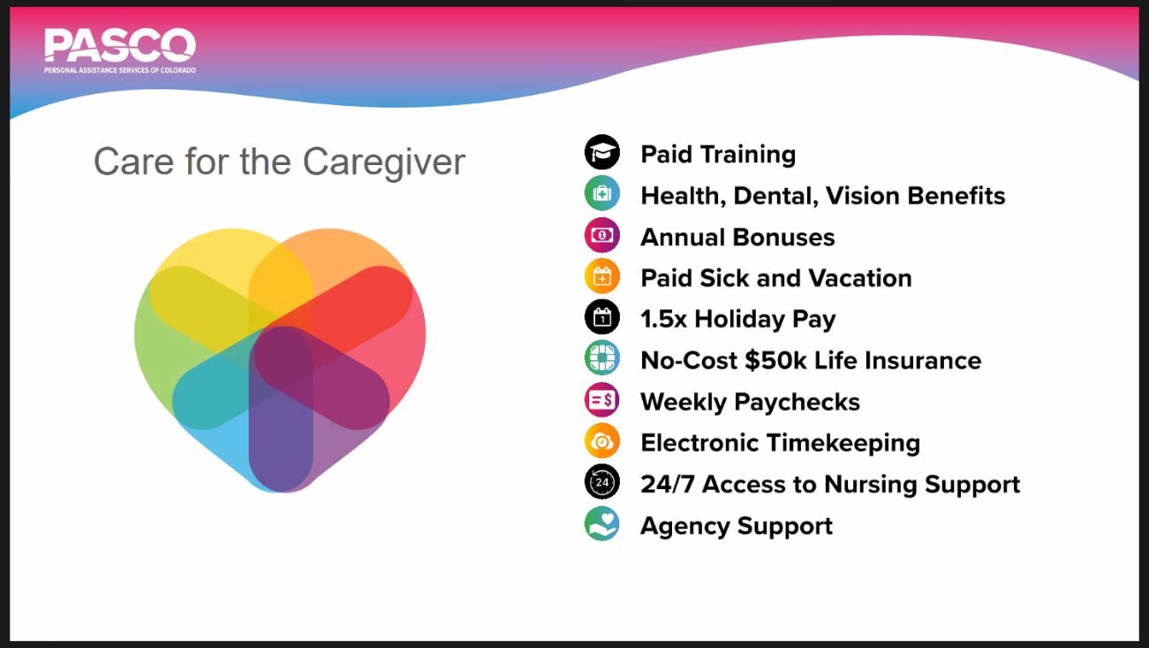

G-Tube training at no cost

State of Colorado Pediatiric acuity table to determine the number of hours needed to be paid.

School designed by the State of Colorado

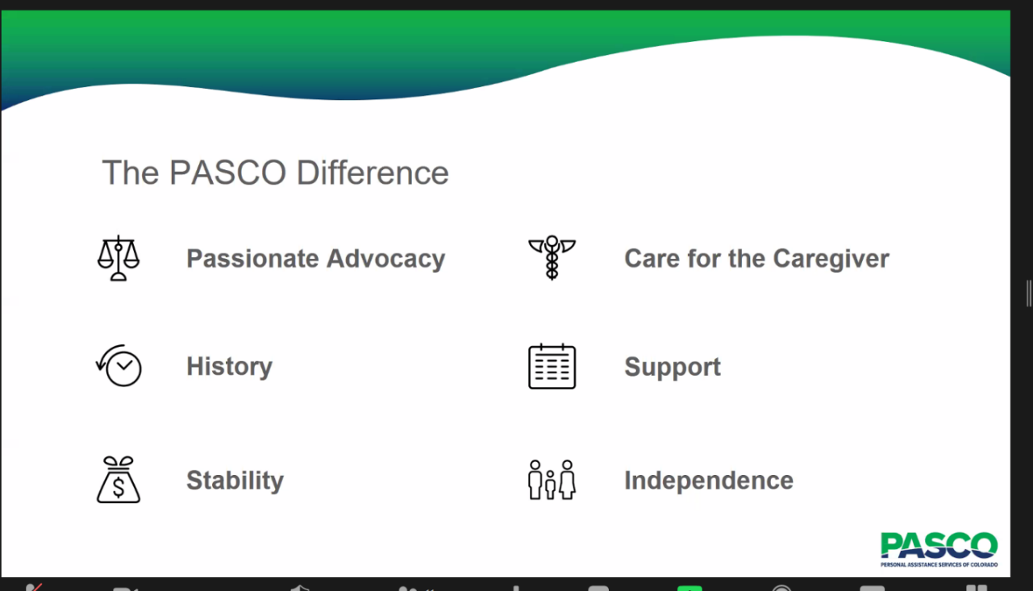

Used for children with medical complexities in care management program

Win for the State to use Medicaid dollars

This model is very beneficial for families in Colorado

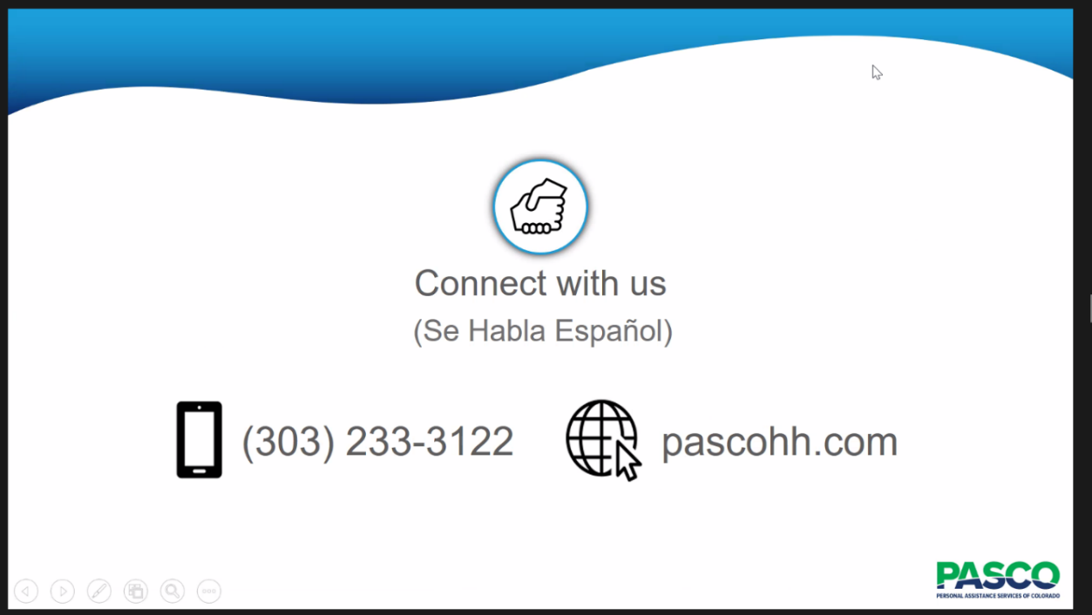

Jenny Krupa
What is the sign up process – families call PASCO send a note via website or call to speak with intake. If they are on Medicaid it is quicker or they guide them through Medicaid. They can apply through Children’s Hospital. Longer process if not with Medicaid.

They partner with 10 different CNAs schools.

In home support services can start in 10 days.

They follow up with families every two weeks. Process with program is longer with Spanish speaking individuals. They have bilingual adminstration and nurses.

Dr. Potter – there is a waiver if both parents are working, the child needs services. The waiver does not include the income.

The number of potential clients, seems very high. Are you aware of the potential clients you have, waitlist, budget constraints

Our CEO, we would love to help as many people as possible. They are for profit. There is an increase in services at PASCO. When it started it was a program too good to be true. There is a joke, there is no way I could be paid to take care of my son or daughter. We have seen a lot of agency roots in advocacy. Maribel loves her job, she serves the Spanish speaking community and works with Children’s Hospital Colorado.
Please share information about PASCO. They pay for 2 caregivers to go to CNA school.
People don’t know enough about the disability community.

Community Center Board Entry Points – She works with them. Help Educate Families. There is a stigma with Medicaid.

John – As someone who has worked with Medicaid billing. How much training do they get if they are in compliance so that the families are protected. We have a full team that is administrative. They have a full compliance team, HR, Nursing, and the state has requirements in place. They also have another process, they monitor and build strong relationships with families.

Acquired TBI, they work with Craig Hospital

They do home modifications and seek waivers

Biggest challenge for 65 and older not being on Medicaid and Medicare - Often have assets

Shortage of community care.

They have 130 CNAs providing care to people on wheelchairs. Hard during COVID to get them.

