Foundations in Patient Safety

M&M Playbook

Step 1: Case Selection

Please provide a one-liner of your case:

What was the adverse event?

What was the level of harm to the patient?

What potential errors contributed?

Step 2: Analyze the Case

Create a Cause & Effect Analysis (Fishbone Diagram)
Free template available here: https://templates.office.com/en-us/cause-and-effect-diagram-tm06082737

Step 3: Prepare the Conference

Identify the Stakeholders:

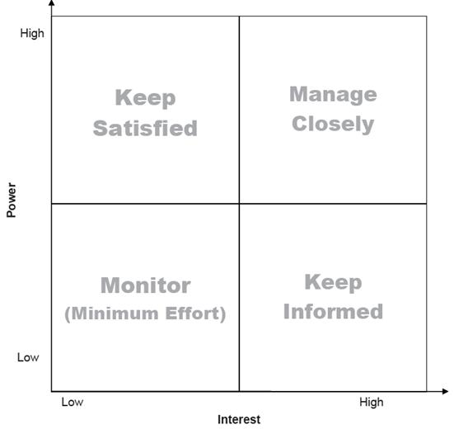

Step 3: Prepare the Conference

Identify Learning Objectives

- Medical Objectives i.e. Guidelines or Best Practices

- Quality Improvement Objectives i.e. Quality and Safety Practices

Step 4: Identify Action Items

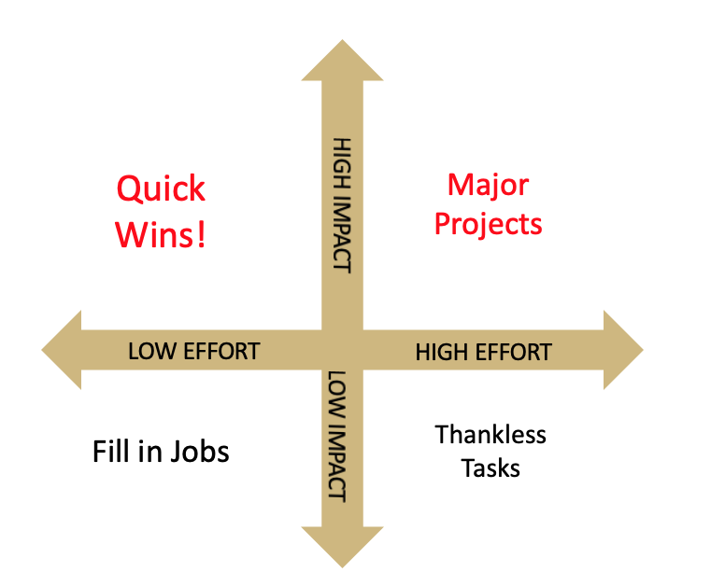

Which patient safety concerns are actionable?

Who is your support team?

How can you align these action items with organization priorities at UCH?

