Key Is In The Healing!

Meeting: CU ACC Diversity and Inclusion Meeting

Date and Time: Friday, March 26, 2021, 12:45 pm to 1:50 pm

Location: Online Zoom

Attended by:

Dawn Walton
Huntington Potter, PhD
Samantha Holden, MD
Karen Orjuela, MD
Nicole Gonzales, MD
Heidi Chial, PhD
Christina Coughlan, PhD
Athena Wang, PhD
Md. Mahiuddin Ahmed, PhD
Noah Johnson, PhD
Paula Grissom
Grace Fishback
Deanna Ragsdale
Lexer Duque Sanchez
Erika Dallmann
John O’Shaughnessy
Polly Serrano
Haley Steinert
Katrina Bengtson
Jessica Cline
Natalie Lopez-Esquibel
Francesca Dino
Trevor Sooy
Michelle Stocker

Notes:
Presentation from Dawn Dalton

Presented TRAUMA * IDENTITY * PRIVILEGE
Website: www.ParticularandPowerful.com

Dawn recommended the following book:

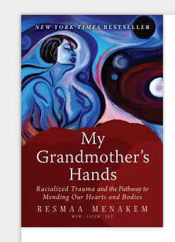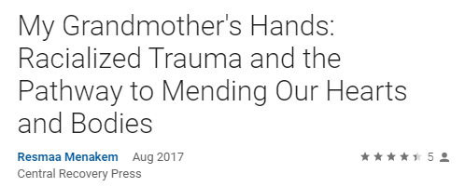

Transformative power of education, healing is not an option.

Healing from trauma is the work.

Concept of Privilege we define it as a special set of advantages or a group of people. We complain that the advantage is:

Special Advantages
Granted
Unearned Invisible

They lead to a better outcome:

Abstract
Relative
Contextual

Maybe – Blindness, Social Obstacles,

Maybe Not- Obliviousness, Lacking Wealth

Traits that are unfortunate and fortunate in different situation.

Types of Privilege – Main Types Socioeconomic, Racial, Gender, Sexual Orientation, Religious
Other Types of Privilege: Education, Intact Family, Language, Age, Height, Beauty, Fit, Coupled, Birthplace/Geography, Access, Living in Peace, and the privilege of Not being traumatized.

Privilege is an abstract concept that should not be used to justify concrete:

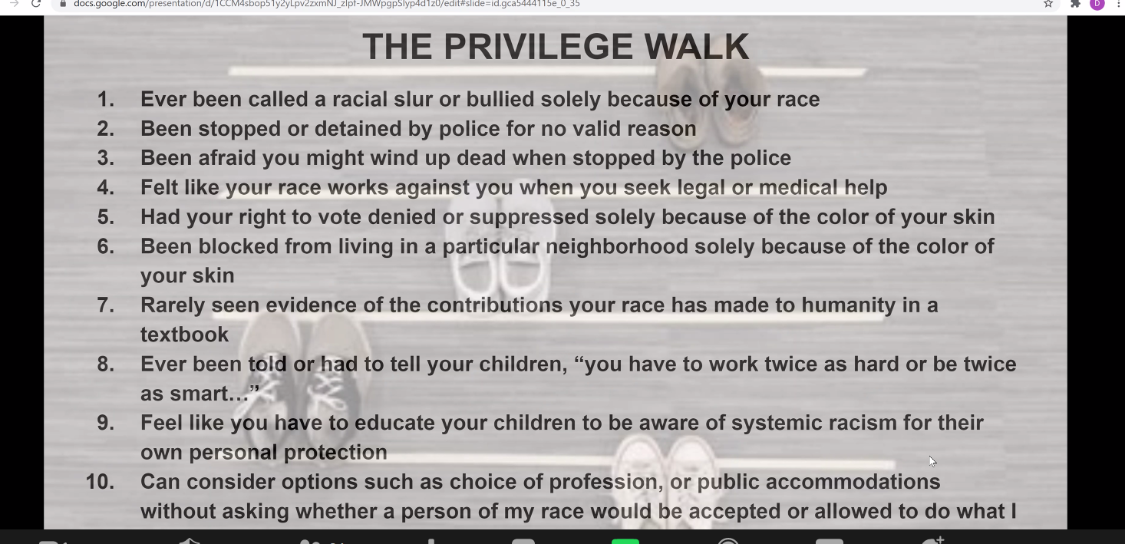

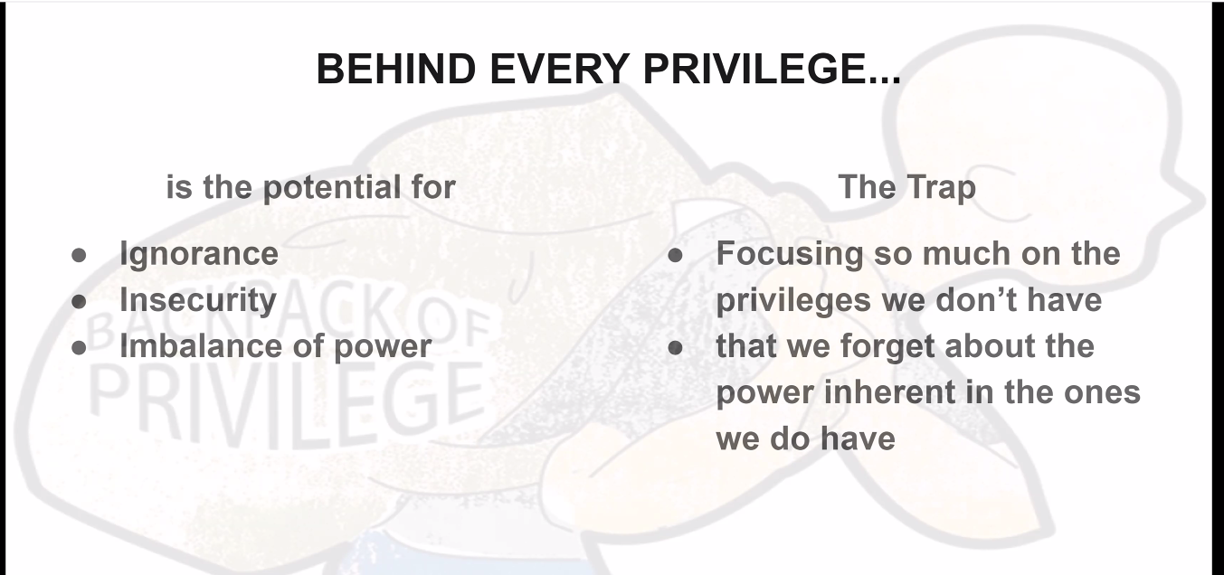

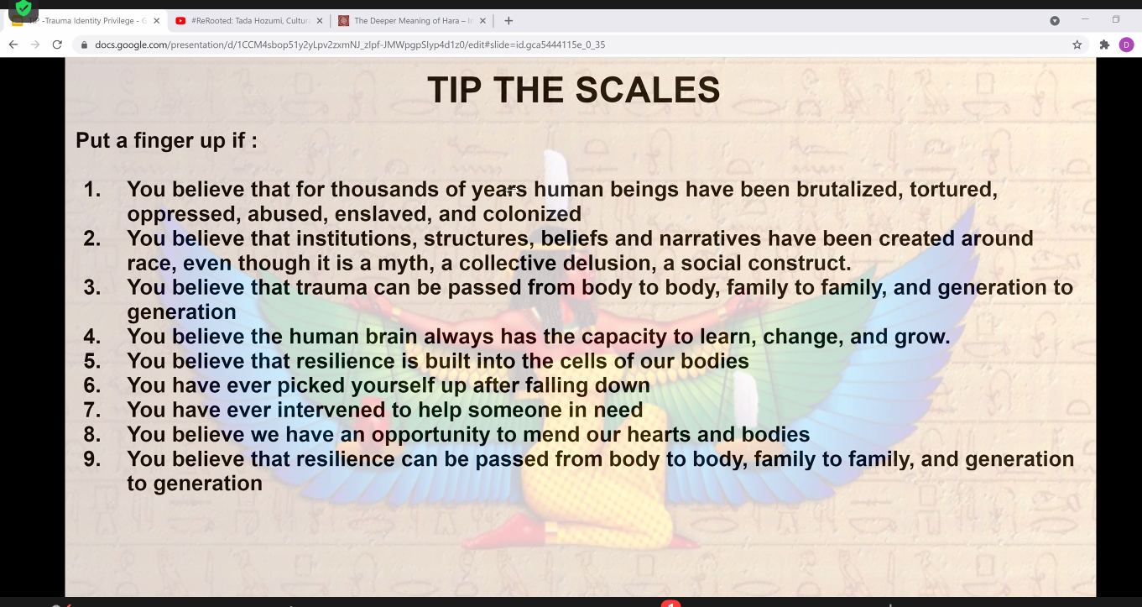

https://hbr.org/2013/12/how-diversity-can-drive-innovation

Dr. Potter – commented on discussion regarding wealthy children feeling abandoned, different in emotional response to trauma. If you are wealthy, it allows other stresses. Approached to other things in their life. Sam’s point to make it a talk about the nuances of privilege.

Discussions from Dr. Holden on obstacles and types of privileges as well as non-privileges. Michelle, Jessica, and John also discussed personal challenges and methods to use for understanding. Heidi asked how we can help.

Discussion regarding Cultural Semantics too.

